Analytical X-Ray Safety Interlock Tests

To be conducted every six months per NJAC 7:28-21.6

Machine __________ Manufacturer: _______________ Model _____________
Serial# ___________ DEP registration # ____________ Room _____________

Date | Item | Initials
 | “X-Ray On” warning light functional?
 | Sample chamber door locks when machine on?
 | All users possess dosimetry?

Date | Item | Initials
 | “X-Ray On” warning light functional?
 | Sample chamber door locks when machine on?
 | All users possess dosimetry?

Date | Item | Initials
 | “X-Ray On” warning light functional?
 | Sample chamber door locks when machine on?
 | All users possess dosimetry?

Date | Item | Initials
 | “X-Ray On” warning light functional?
 | Sample chamber door locks when machine on?
 | All users possess dosimetry?

Date | Item | Initials
 | “X-Ray On” warning light functional?
 | Sample chamber door locks when machine on?
 | All users possess dosimetry?

Date | Item | Initials
 | “X-Ray On” warning light functional?
 | Sample chamber door locks when machine on?
 | All users possess dosimetry?

Portable/Handheld X-Ray Device Log

Machine __________ Manufacturer: _______________ Model _____________
Serial# ___________ DEP registration # __________ Storage Room _____________

Date | User Initials | Purpose | Location (Room Number) | Problems or Issues
Example: Take a photo of machine to add to EHS files and post on machine.

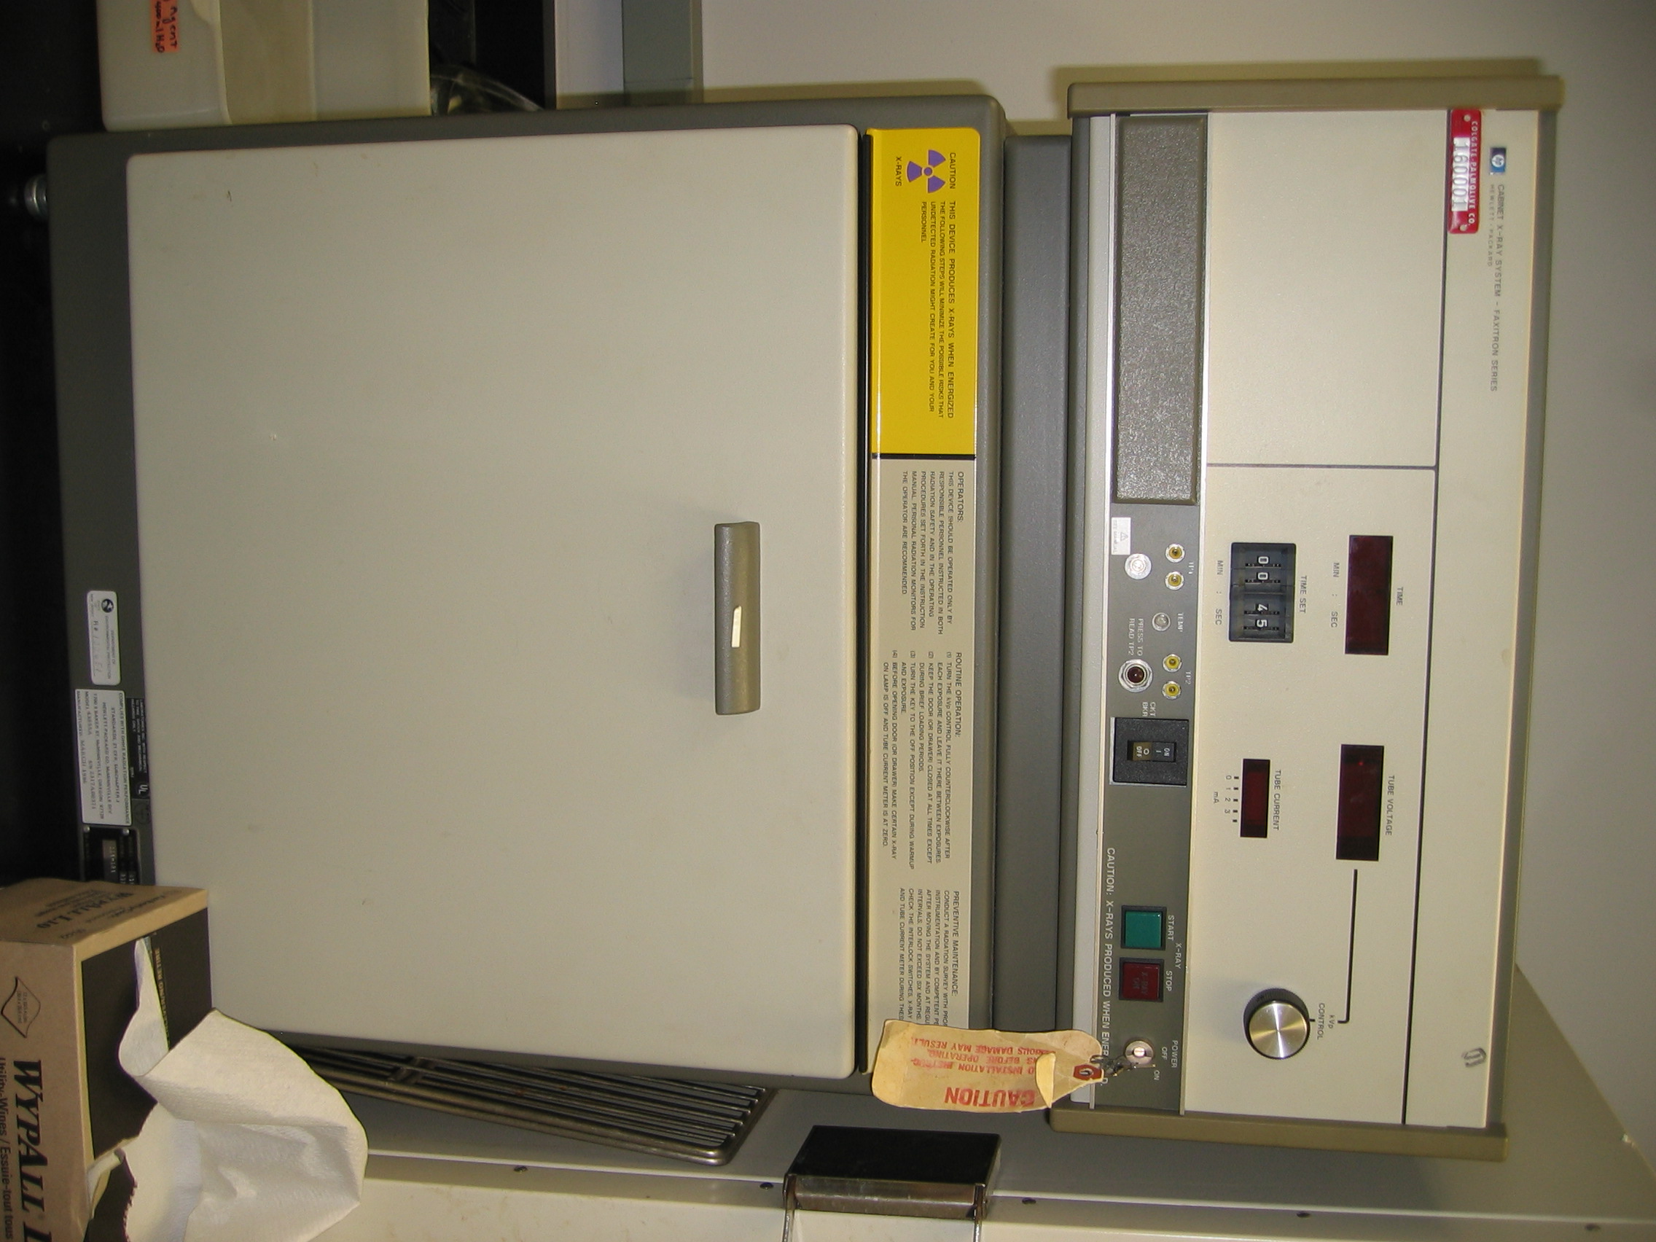

Hewlett Packard Cabinet X-Ray

DEP Registration # 102651

Contact Irene Petrova

