Banner 9 Finance
Navigation and Documentation

financesecurity@njit.edu
Financial Systems & Innovations
Fenster Hall Room 550
Newark, New Jersey 07102

- Introduction to Banner 9 administrative pages:
  - Welcome and Navigation 4-5
  - Forms Navigation 6
  - Administrative Banner Short Cut Keys… 8
  - Set Preferences 9
  - My Banner – Personal Menu 10
  - Download to Excel… 11
- Frequently used forms… 12
  - Navigate FGIBDST- Organization Budget Status. 13
  - Navigate FGITRND- Transaction Detail. 14
  - Navigate FRIGITD- Grant Inception To date… 17
  - Navigate FTIIDEN – Vendor Information 18
  - Navigate FGIJVCD- Incomplete Documents… 19
  - Navigate FOIDOCH – Document History… 20
  - Navigate FAIVNDH – Vendor History… 23
  - Navigate FAAINVE – Invoice Entry… 25
  - Navigate FPAPURR – Purchase Order Entry… 29
- Administrative Banner Error Messages… 33
- Appendix
  - Appendix A… 34
  - Appendix B ( Banner Rule Classes)… 35

Menus: Select the three lines at the top left menu. This is the shortcut menu to Banner Forms. The Menu is grouped by Functional modules.

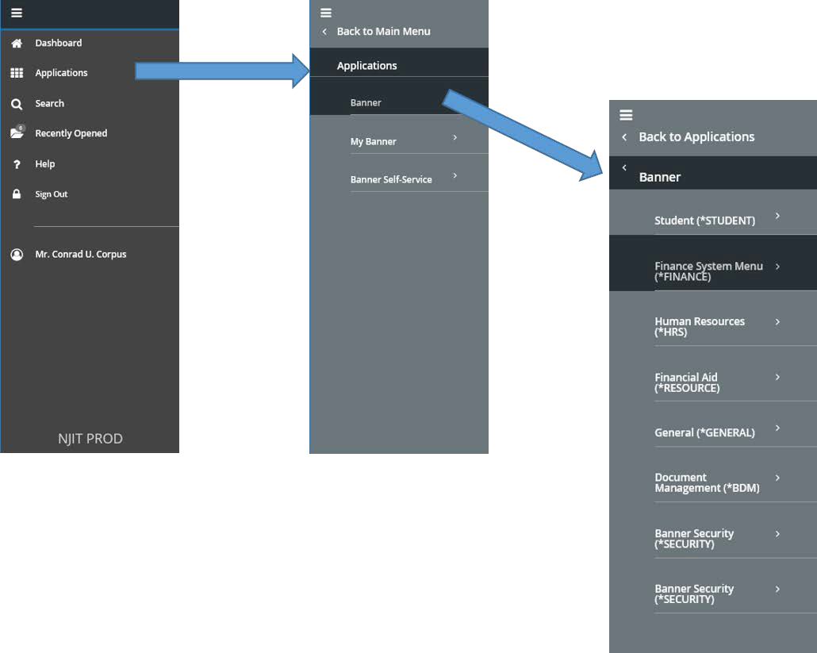

The Welcome Screen:
- User’s Name at the bottom left (Left Sidebar).
- Button to log out. You can also close the browser to log out.
- Search bar in the middle of the screen.
- Pop out menu.
- Search that stays on the top of the screen.
- Folder to access recently used forms.
- Application Navigator.
- Shortcut Keys menu.
- Ellucian Applications.

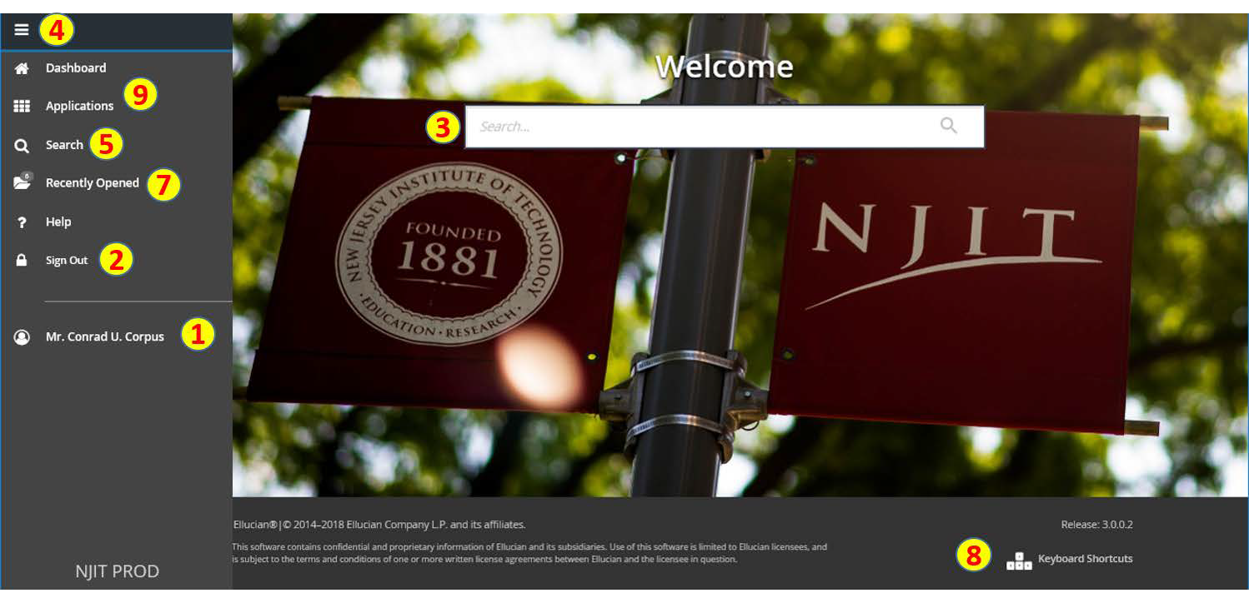

Use the Search bar in the middle of the page. You can search for the description or the form name such as Trial or FGITBAL. You do not need to use the % symbol as your wild card. Suggested forms will display.

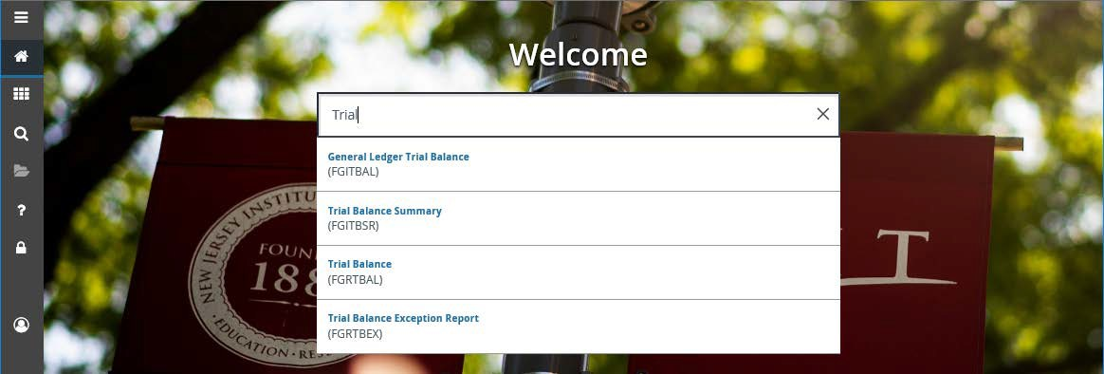

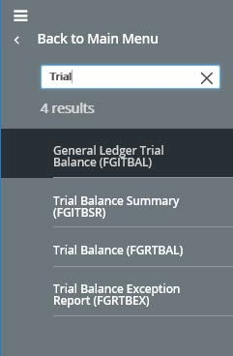

You can also use the search icon at the left of the page to search by form name or description. The search icon will stay at the top of the page when you are on other forms. Therefore, you can access multiple forms with the search.

- Page Header – The page header identifies the open page name and contains icons for basic navigation.
- Related icon – displays a list of pages that can be accessed from this page.
- Tools icon – includes refresh, export, print, clear record, clear data, item properties, display ID image and other options controlled by the page.
- Main Key Block – the first block on most pages contains key information.
- or Alt+Page Down is the new Next Block to display information.
- Add – Add documents to Banner Document Management.
- Retrieve – Retrieve scanned documents from Banner Document Management.
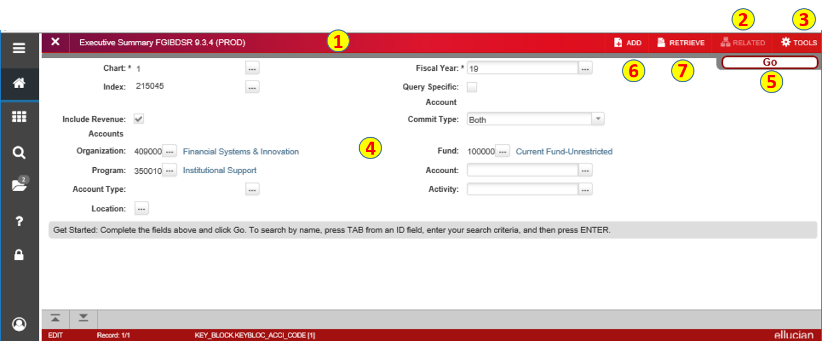

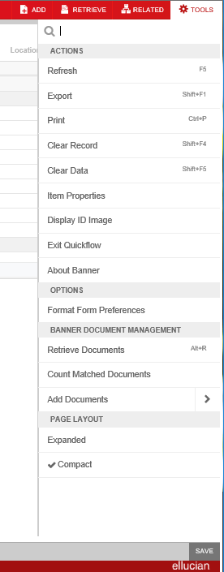

- Scroll to next page: The button will change to and is the new rollback.
- Displays the search criteria used to access FGIBDSR information.
- Detail section.
4. User has option to go from page to page or display more than 20 lines per page.
5. Used if the form is a data entry screen.
6. Next/previous section.
- X is used to exit the form or CTRL +Q.

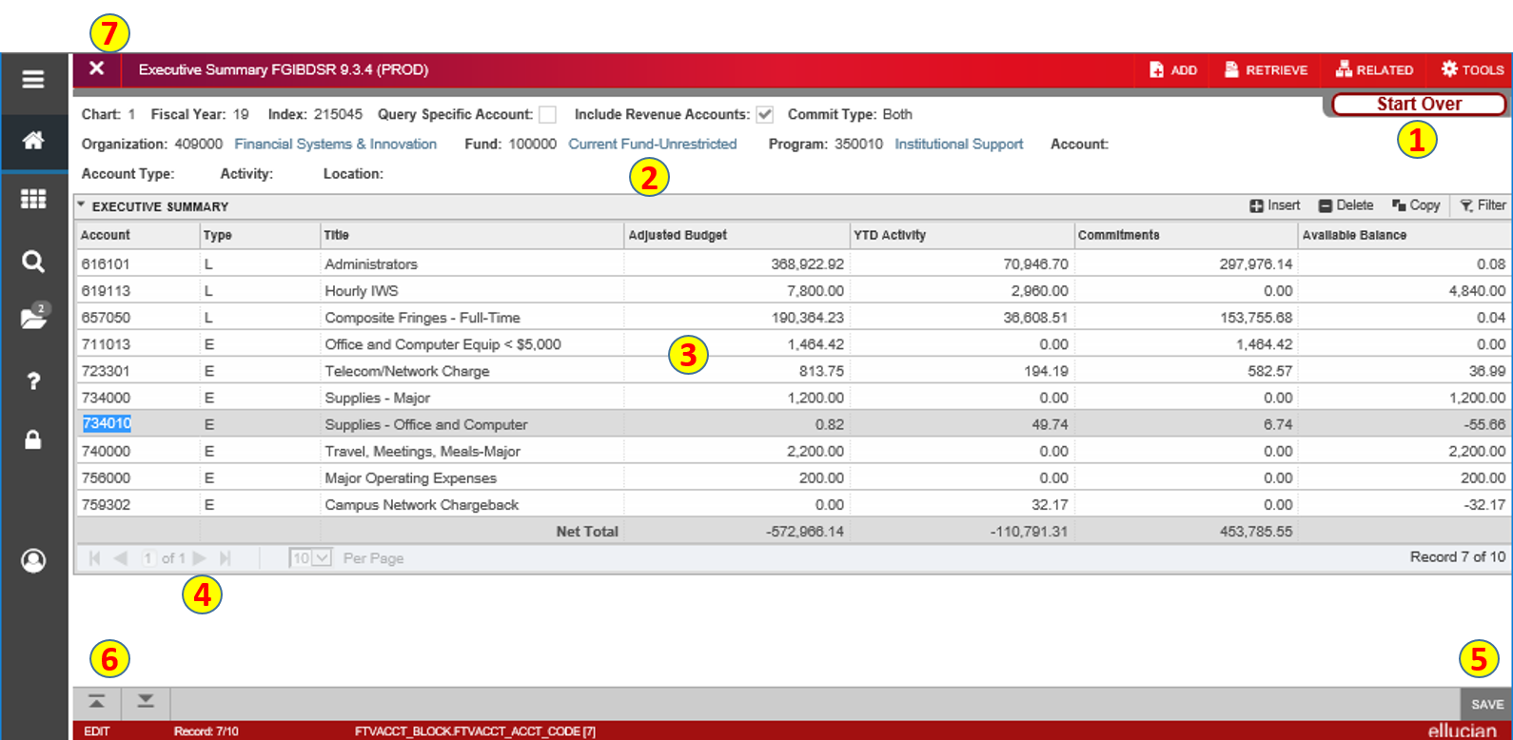

Banner 9 Shortcut Keys

Function | Key Stroke |  | Function | Key Stroke
Next Field/Item | Tab |  | Save | F10
Previous Field/Item | Shift + Tab |  | Clear one Record | Shift + F4
Up | Up Arrow |  | Delete Record | Shift + F6
Down | Down Arrow |  | Duplicate Selected  Record | F4
Previous Page Up | Page Up |  | Insert/Create Record | F6
Next Page Down | Page Down |  | Clear All in Section | Shift + F5
First record | Ctrl + Home |  | Open Menu Directly | Ctrl + M
Last record | Ctrl + End |  | Next Section | Alt + Pg Down
Search list of values | F9 |  | Previous Section | Alt + Pg Up
Cancel page, Exit, Close Current Page,  Cancel Search or Query | Ctrl + Q |  | Duplicate Item | F3
Export | Shift + F1 |  | Clear Page/Start Over | F7
Print | Ctrl + P |  | Execute Filter Query | F8
Refresh/Rollback | F5 |  | Paste | Ctrl + V
Change MEP Context | Alt + Shift + C |  | Undo | Ctrl + Z
Open Related Menu | Alt + Shift + R |  | Redo | Ctrl + Shift + Z
Open tools Menu | Alt + Shift + T |  | Cancel Action | Esc
More Information | Ctrl + Shift + U |  | Select on a Called  Page | Alt +S
Application Navigator Display | Ctrl + Y |  | Retrieve BDM  Document | Alt + R
Application Navigator  Search | Ctrl + Shift + Y |  | Add BDM  Document | Alt + A
Application Navigator  Help | Ctrl + Shift + L |  | Submit Workflow | Alt + W
Copy | Ctrl + C |  | Release Workflow | Alt + Q
Cut | Ctrl + X

Set Preferences
Set Your Preferences so you can:

- See Column Header Records when you download to Excel
- See the names of the screens on My Banner
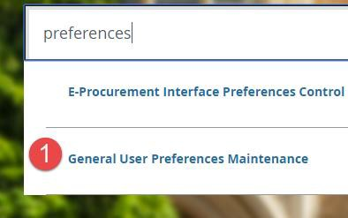
    - In the search bar, type Preferences. Select General User Preferences Maintenance.
    - In the Display Options tab, make sure all the boxes are checked on the left side of the page. By default, the second and last ones are not checked.
    - Save
    - Close

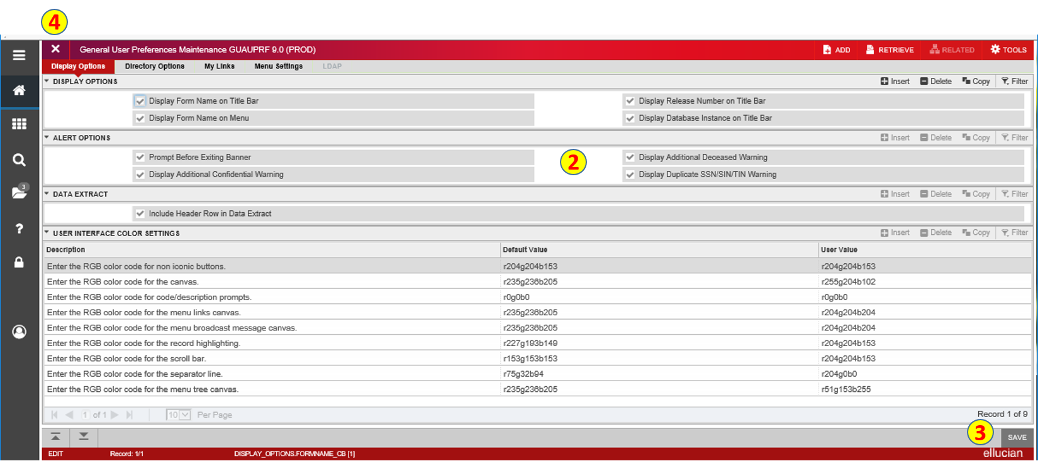

My Banner – Personal Menu
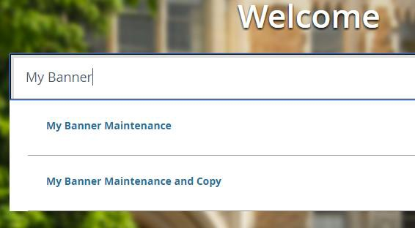
You can create shortcuts in My Banner so you do not have to memorize or search for the correct screen.

Search for My Banner.
Select My Banner Maintenance.

If you have never setup Banner Shortcuts, you will see an empty form on the right side.
- Type a form name in the Object column on the right side (ex. FOIDOCH)
- Tab once to allow the description to be populated. The description will show in your shortcut. You can change descriptions if you wish.
- When you are finished choosing common forms, you can save and close the form.

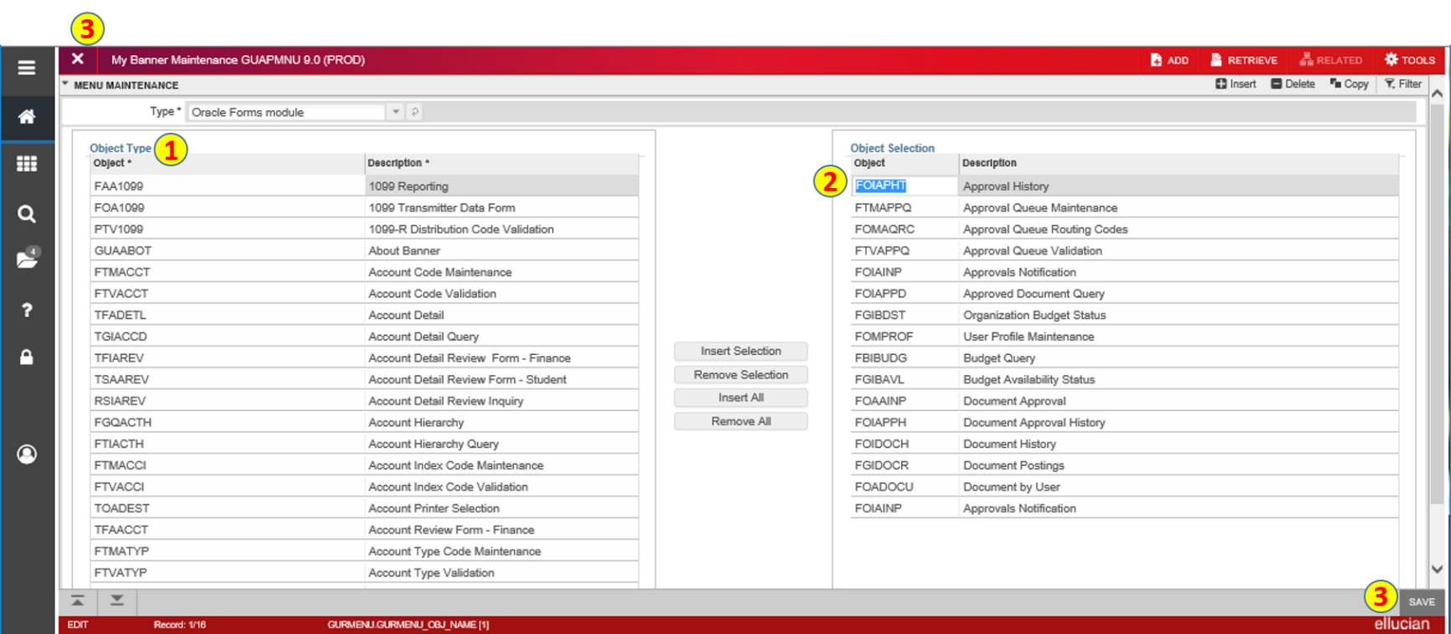
Excel - Download
You can download FGIBDST and other forms into an Excel Spreadsheet. To download to excel:
With your Budget open in FGIBDST. Select Tools or the Gear Icon from your top right menu. From the drop Down Menu, select Export.
Your file will appear that the bottom left of your page as a .csv file and will open in an excel spreadsheet.
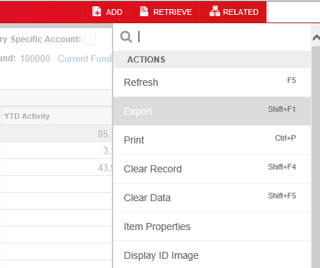

You can save the file as an Excel Worksheet and then perform calculations. Depending on the browser, you might get the following message if you are using Internet explorer:

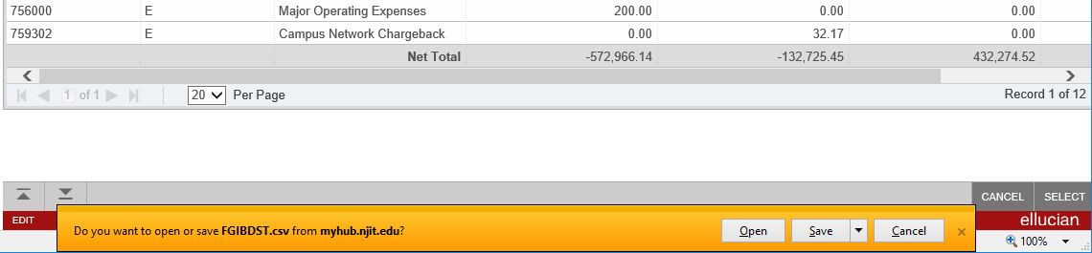

Frequently Used Forms
Recommended Finance forms for My Banner:
FOIDOCH | Document History – find PO, Requisition, Invoice, Check and receiving History
FPAREQN | Create a Requisition
FGIBDST | Organization Budget Status
FGIBDSR | Executive Summary
FGITBAL | General Ledger Trial Balance
FGITRND | Transaction Detail
FGIOENC | Open Encumbrance list
FGIBAVL | Budget Availability Status
FGIGLAC | General Ledger Activity
FGIENCD | Encumbrance Detail
FAIINVL | Invoice/Credit Memo List
FRIGITD | Grant Inception to Date
FRIGTRD | Grant Transaction Detail Form
FGIDOCR | Document Retrieval Inquiry
FOAIDEN | Person identification Form
FTVFUND | Fund Code Inquiry
FTVORGN | Organization Code Inquiry
FTVACCT | Account Code Inquiry
FTVPROG | Program Code Inquiry
FTIFATA | FOAPAL Attributes – Financial Statements
FGAJVCD | Journal Voucher Entry
FPAPURR | Purchase Order
FTVCOMM | Commodity Code Validation
FAIVNDH | Vendor Detail History

Budget – FGIBDST
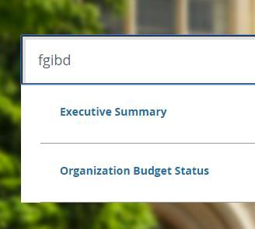
In the Search, enter FGIBDST and enter to go to the form.
Enter Budget Information:
Enter Chart of Accounts. Enter Fiscal Year.
Choose Both for Commitment Type from Drop Down You can Include Revenue Accounts if it applies.
Enter Organization and Fund Code. Select the button
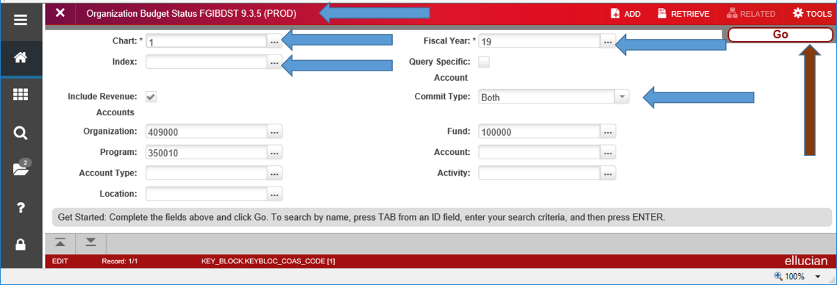

The Budget will fill in the next Block. Use the Scroll on the right to see the rest of the budget.
Account Type and Title – Spending category.
Adjusted Budget – Budget after Transfers
YTD Activity – total Payments/Transactions completed to date. Includes items invoiced.
Commitments – total of both Requisitions (Reservations) and open Purchase Orders or Travel Encumbrances
Available Balance – Current Amount Available. To clear form and view different Budget, select .
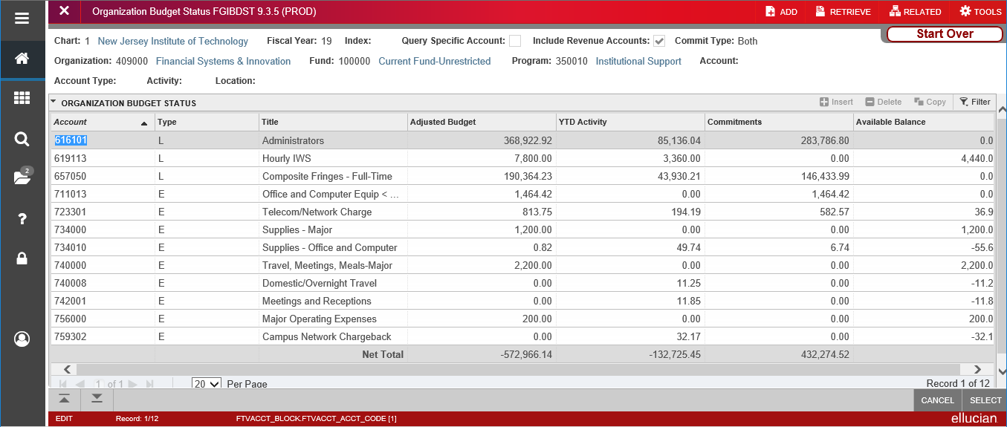

FGITRND - Review Budget Transactions

To review all the details of your transaction or to see related forms, select Related and choose FGITRND for Transaction Detail

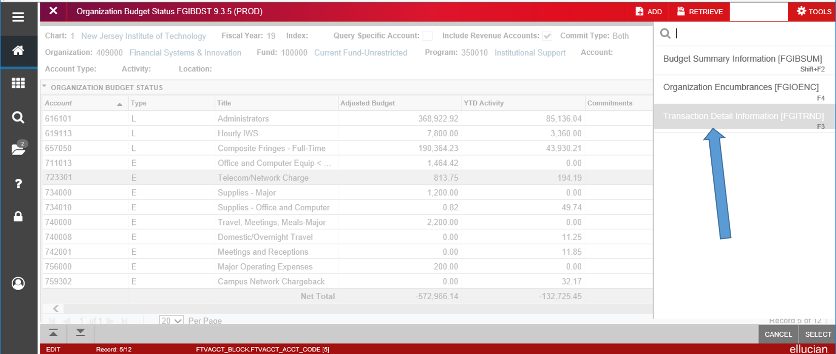

Filter or Search
You can filter transactions to see all or specific line items. To filter transactions choose the drop down menu, Add Another Field.
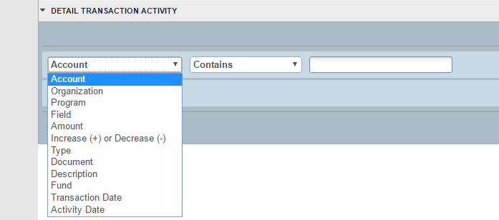
From the middle drop down menu, select appropriate options.
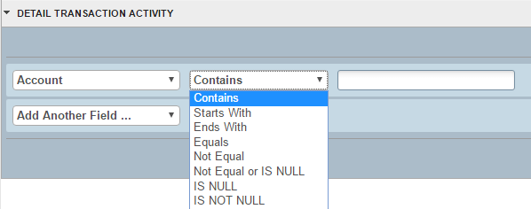
Enter Search Criteria and choose . Results from the filter will be displayed. You can double click on the required field, or choose Select from the bottom right of the screen.

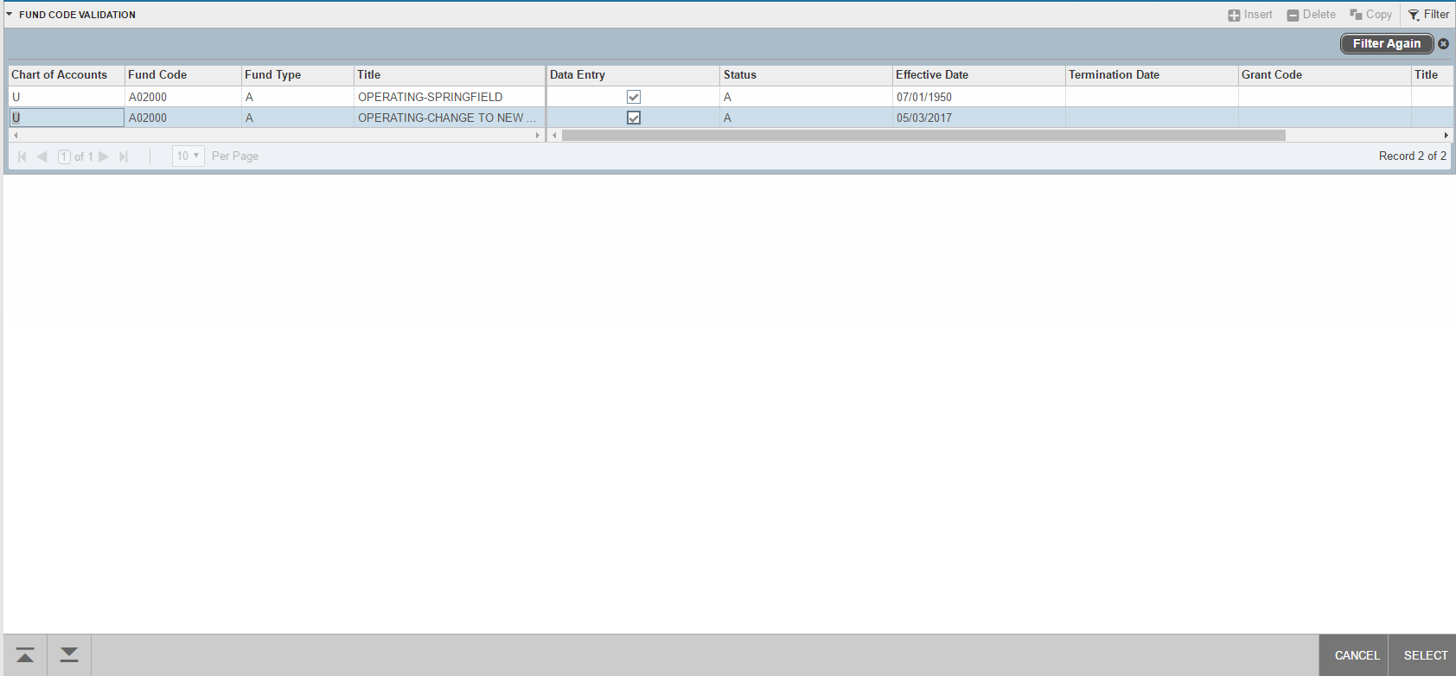

Choosing Select, will take you back to FGITRND or the initial Query page.
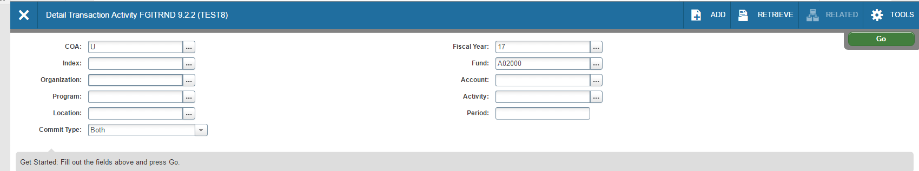
Clear All will remove all entered criteria and allow you to redo the criteria. You may also Export the filtered content into Excel.
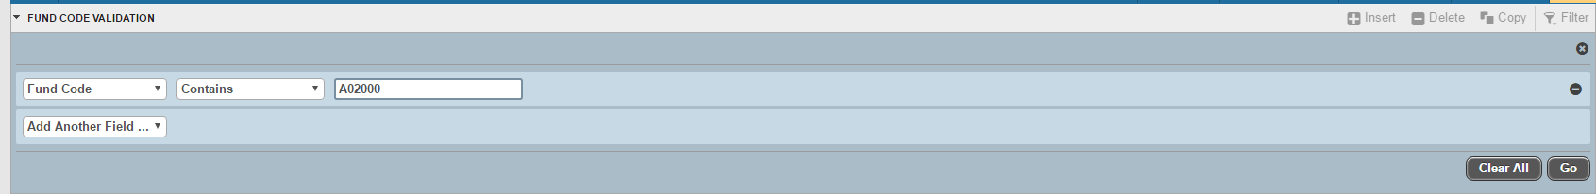

Once you choose . You will be directly taken to the Query Screen. You can exit the query screen to see ALL options. The default number of records per page is 20. Scrolling through the rows will automatically move you through the pages.

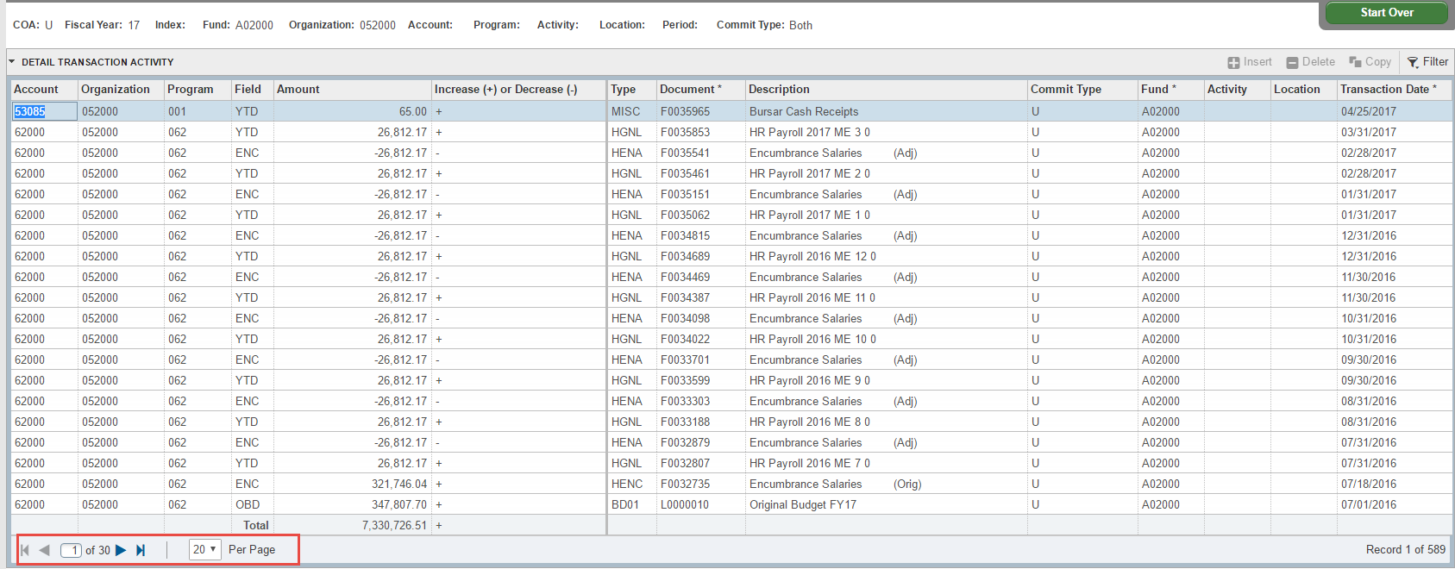

Grant Budget History - FRIGITD
The FRIGITD form will show you the budget history of a grant from the inception of the grant even if it crosses fiscal years. For instance, if you have a grant that starts Oct 1, it is not easy to see the whole budget going through FGIBDST because it will display the budget based on NJIT’s fiscal year. FRIGITD allows you to see the whole budget no matter Fiscal years.
In the Search, enter FRIGITD Enter Chart of Accounts – 1
In the Grant field enter the Grant Fund Code (you do not need to enter a Fund code or Organization Code).
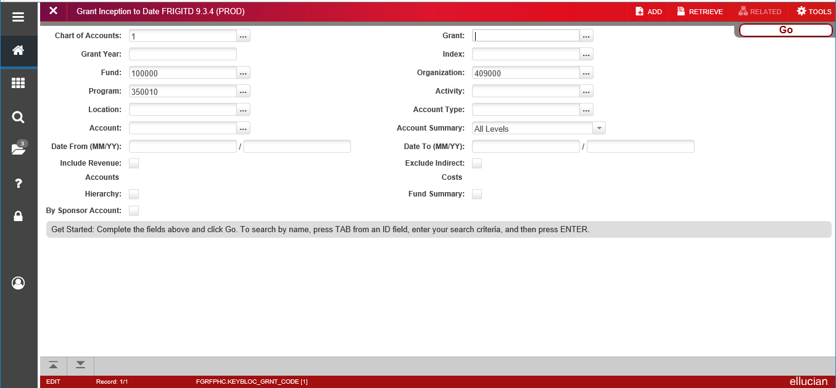
If you enter a Fund code, an Organization code is required. Select the button or Alt + Page Down.

Your Budget will fill below.

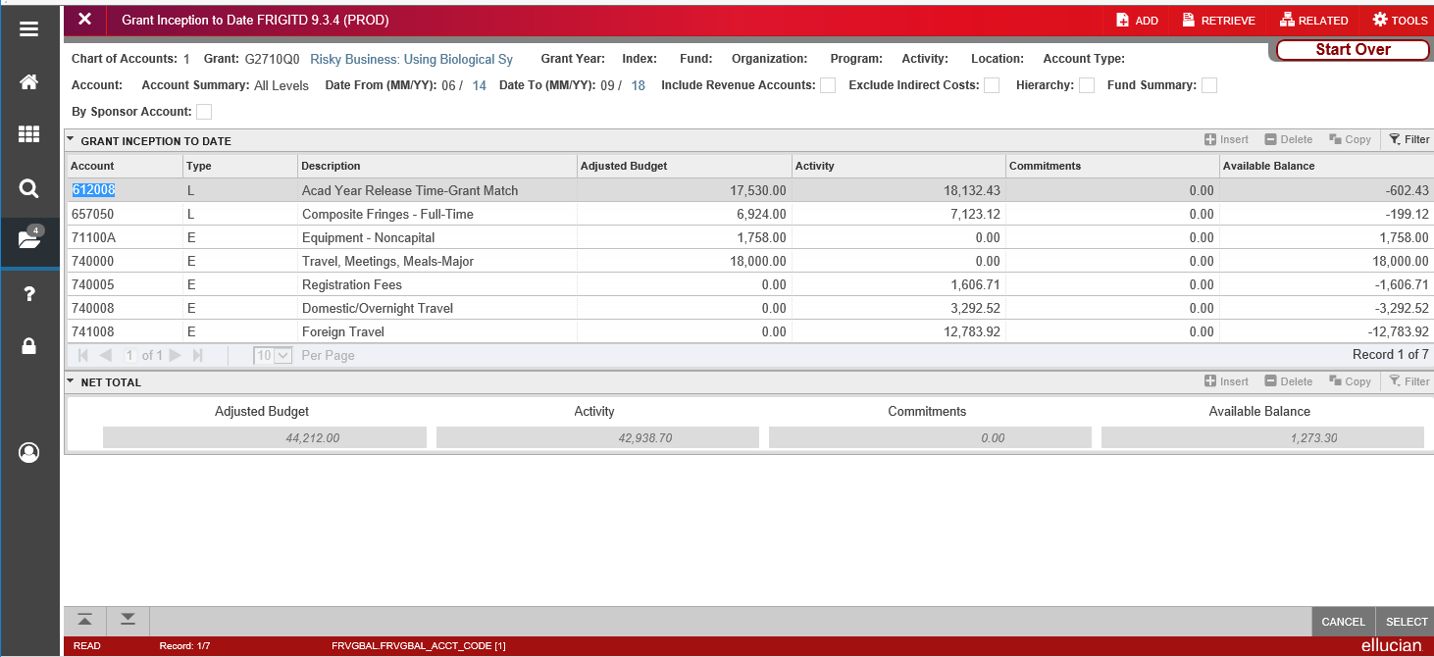
Vendor Information - FTIIDEN

There are a few possible scenarios for vendors:
- You know the Vendor ID.
- You know the Vendor Name, but not the ID.
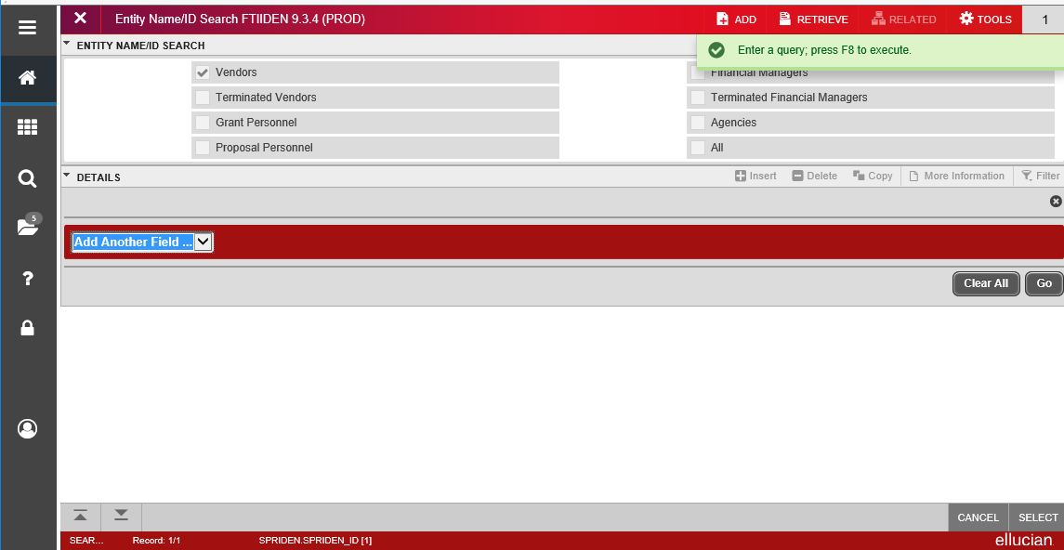
- Your vendor is not in Banner.

- If you know the vendor ID, you can search by Vendor ID.
- If you do not know the Vendor ID
Search for the Vendor ID. If you are on a data entry form, choose the three dots, (
) next to the Vendor ID field and choose from the Option List.

Choose the appropriate dropdown and choose , to run the query.

When sorting through addresses or any form that has multiple records, be sure to look at the record count at the bottom of the page before making a selection.
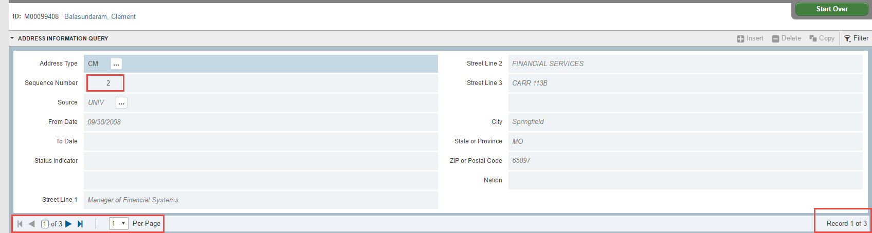

Incomplete Documents – FGIJVCD/FGAJVCD
You can navigate to incomplete documents through FGIJVCD or FGAJVCD to see suspended Journal Vouchers. Double click on the Document you want to edit or choose Select at the bottom right of the page.

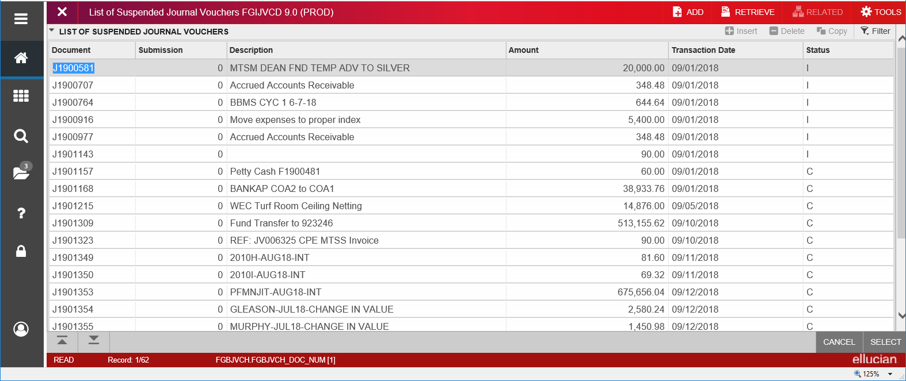

Document History - FOIDOCH
FOIDOCH or Document History allows users to see requisitions, Invoices, Checks Purchase Orders. Document Type is required. Below are some common Document Types:
REQ – Requisition INV – Invoice
PO- Purchase Order CHK - Check
Enter Document Type and Document Code. Searches are allowed on both fields to see possible options. Choose to retrieve results.
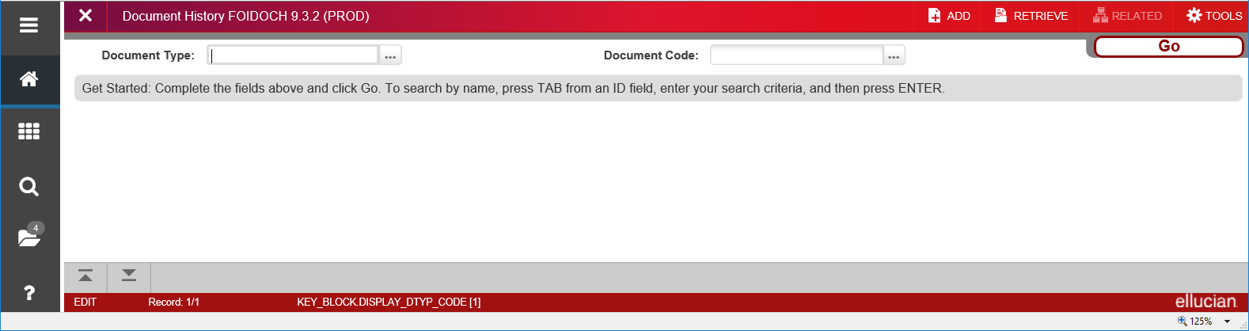
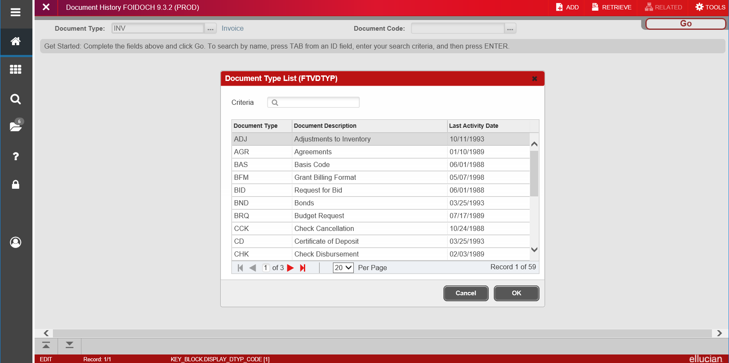

FOIDOCH – Invoice

In the Invoices field, if an invoice has been issued, there will be one or more invoice numbers. Next to the Invoice Number there will be a status code (Blank, P, R, X or S)
Blank – Not yet Paid P – Paid
R – Receiving is incomplete S – Invoice Suspended
X – Invoice was cancelled

FOIDOCH – Check

In the Check field, if the check has been issued, there will be a check number. Next to the Check number there will be a status code (X, F or Blank)
Blank – Newer Check, not yet generated F – Check has been finalized.
X – Check has been voided.
If it is a Direct Deposit (indicated by an ! in the first digit, the status will always be blank) Select the Check Disbursement field.
Select Related – Query Document by Type from the Menu Bar.

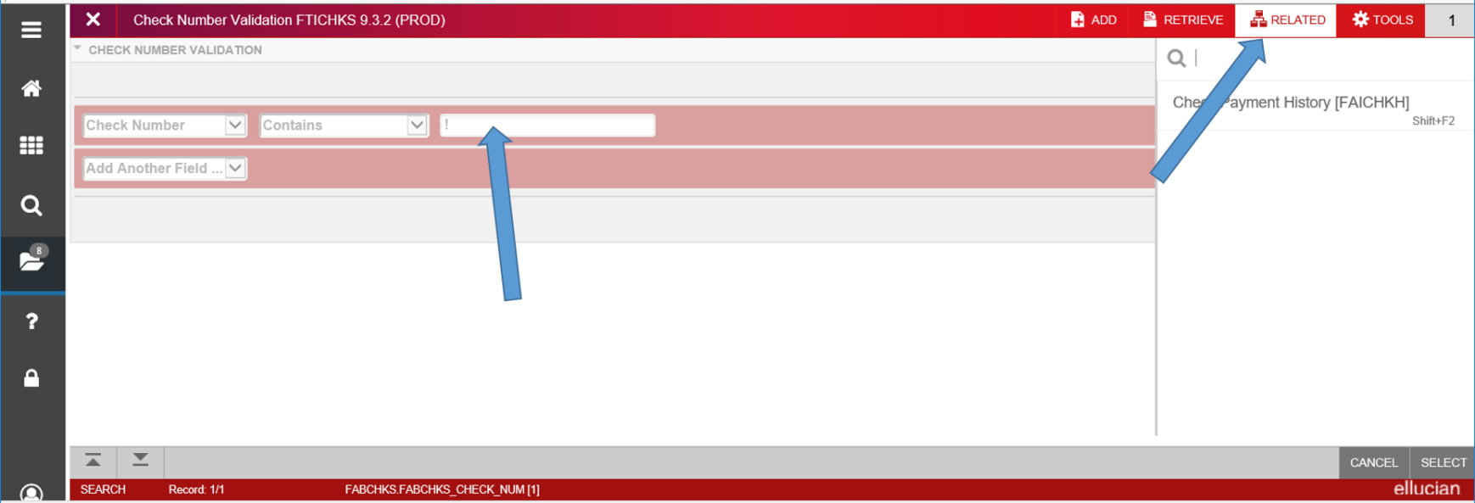

FAICHKH/FTICHKS – Check Payment History
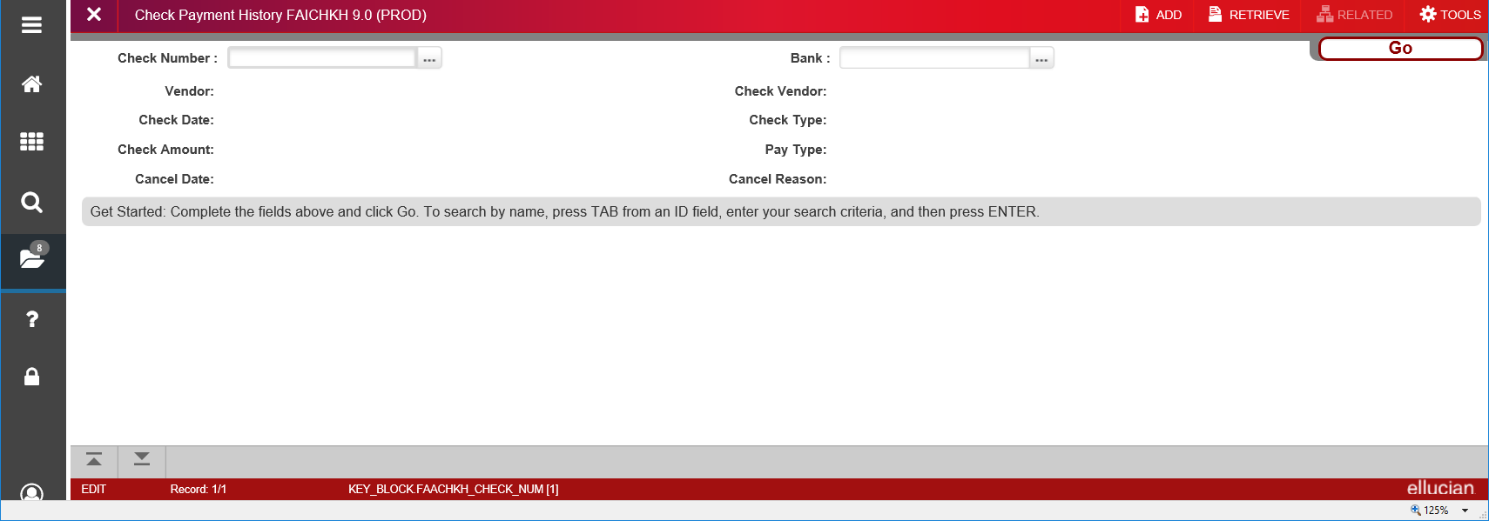
The Check Payment History screen will display.

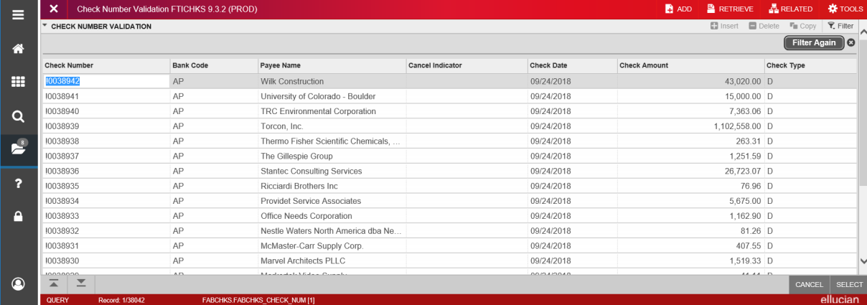
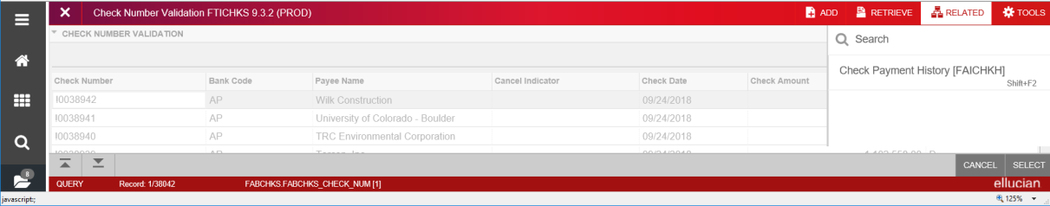
- Check Number
- Check Amount
- Vendor ID and Name
- Invoices paid with this one check
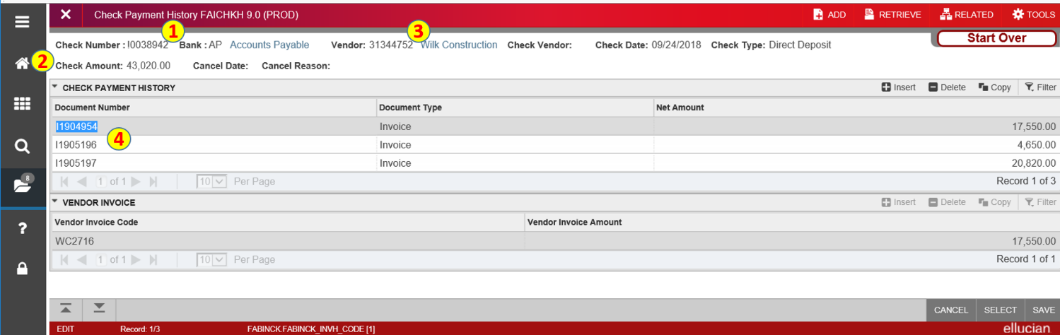

FAIVNDH – Vendor History

Go to FAIVNDH.
Find the vendor by Vendor ID
or select the three dots to search.
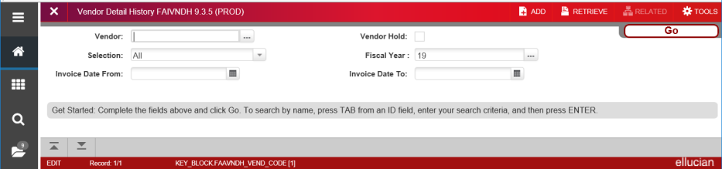

Select Entity Name Search (FTIIDEN)

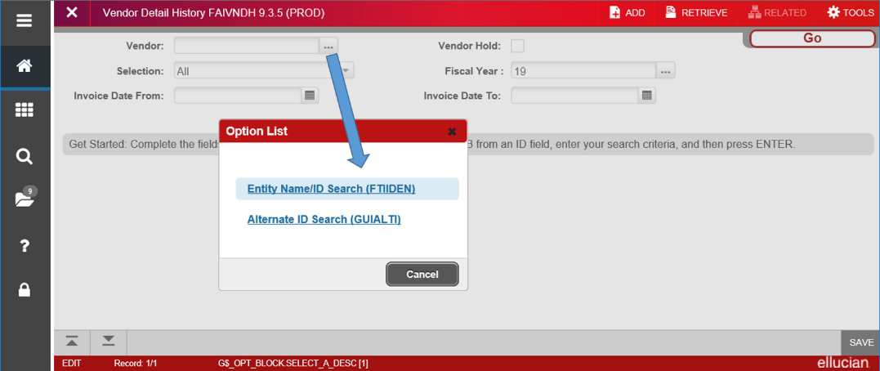

Enter Search Criteria for Vendor. Choose appropriate fields to query against. Select options such as Contains & Equals can be used to search. The percentage (%) symbol is no longer used as the wildcard search. Type vendor name, which is Case Sensitive. Select . Double Click on the vendor you want to choose.

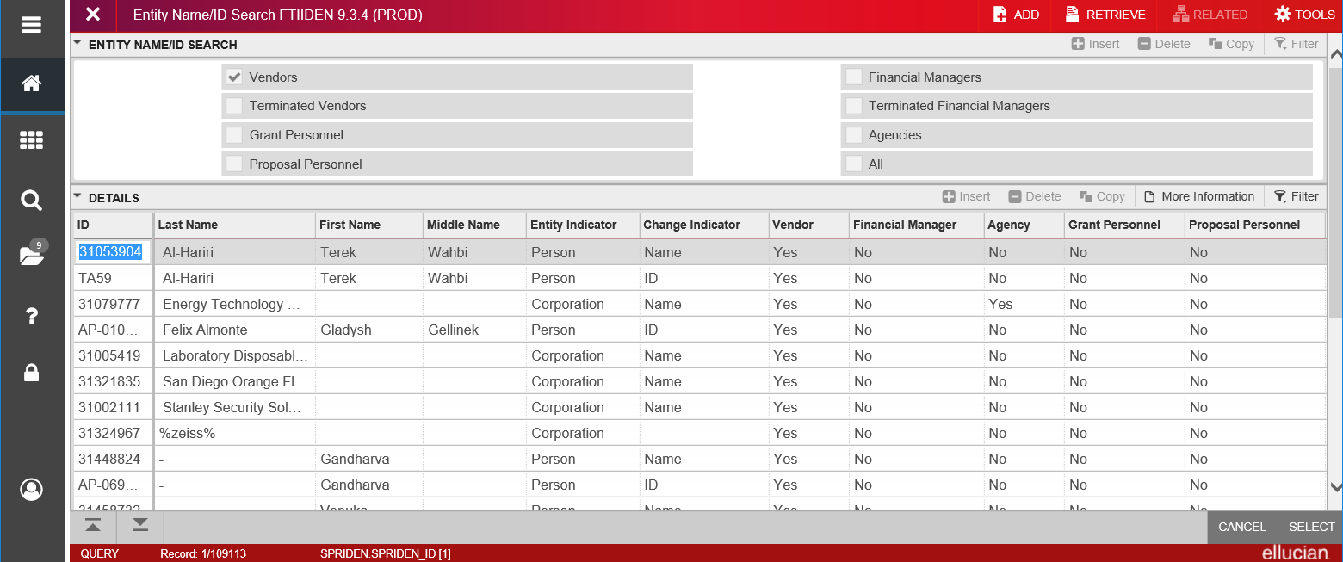

You will be re-directed back to FAIVNDH. With the vendor number filled in. Select to see detail.
Vendor Number and Name.
Vendor Invoice Number and Banner Invoice Number.
Paid indicator shows Invoice was completed.
Vendor Invoice Amount
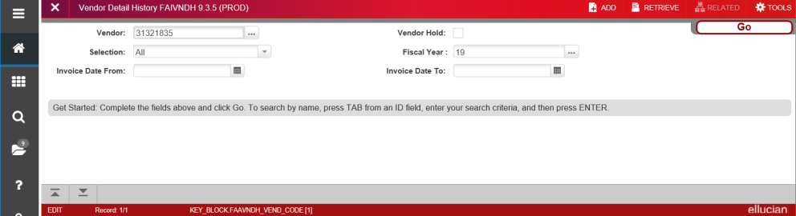
Check Number and Check Date

Invoice/Credit Memo - FAAINVE

To create a new Invoice:
In the search field, enter FAAINVE or Invoice

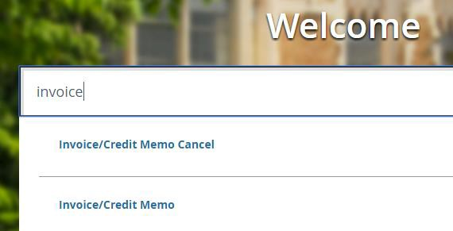

Type the word NEXT for a new Invoice.
- Next will generate the next available Invoice number.
- Choose checkbox to select the multiple invoice option.
- Invoice type includes direct pay, regular – for invoices paid against Purchase Orders and General Encumbrances.
- Enter vendor number or perform a search for Vendor ID.

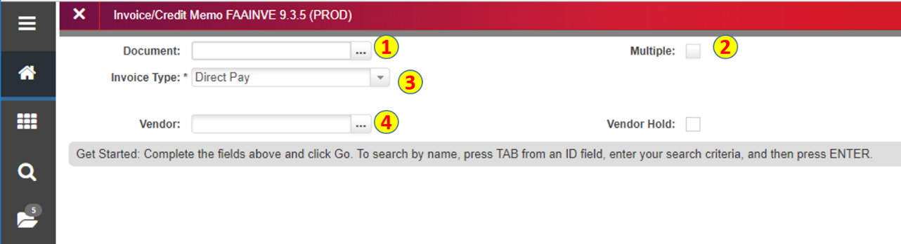

Invoice/Credit Memo - FAAINVE
Click or Alt + Pg Down.
- Enter Invoice Date
- Enter Transaction date
- Enter or select appropriate address
- Enter Payment due date which is almost all the time todays date.
- Enter Bank code.
- Enter vendor Invoice Number
- Choose Credit Memo if it applies.
- Choose Next Section to go to the next section.
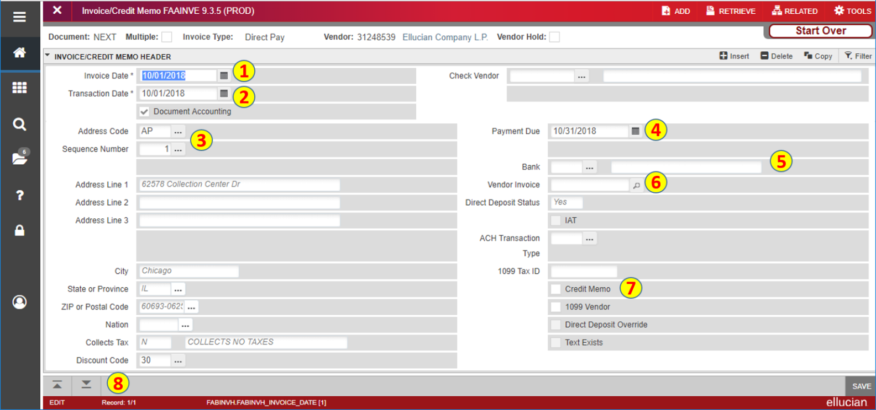

Vendor Invoice Detail:
- Enter Commodity code that applies.
- Enter Approved payment amount.
- Enter any Discounts that apply.
- Check Net Amount.
- To insert another record by using the “copy” button to copy the previous record.
  - Insert will insert a new blank record and will force you to enter the required fields above.
  - Delete button will delete the record. You might get an error message to click Delete again.
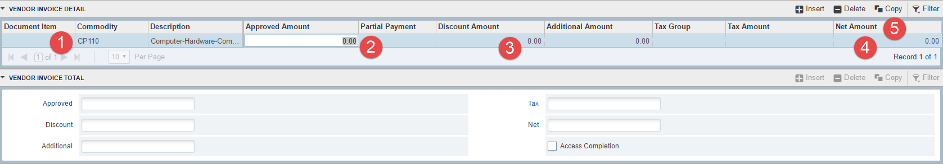
Sequence number and account section:
- Enter Chart of Accounts.
- Tab and year will default to current year.
- Enter Fund Code. You can click the three dots to search a Fund or any FOAP.
- Enter Organization Code if applicable.
- Enter Account Code
- Enter Program Code if applicable.
- Enter Activity Code if applicable.
- Tab or click next section to continue.
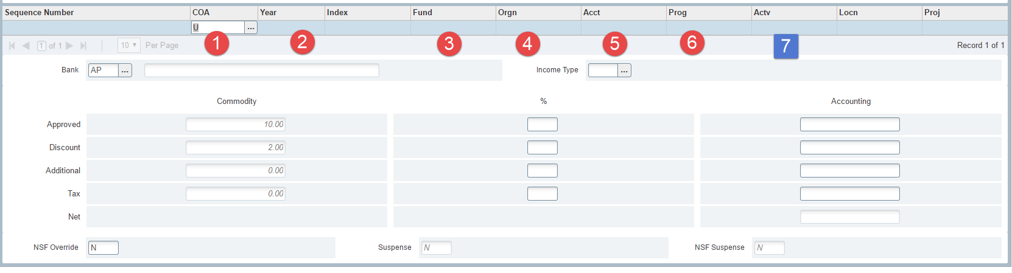

Balancing Completion:
- In Process allows you to save the Invoice and complete at a later time.
- Complete will push the Invoice forward to generate a check or credit memo as applicable.
- Amount of the invoice.
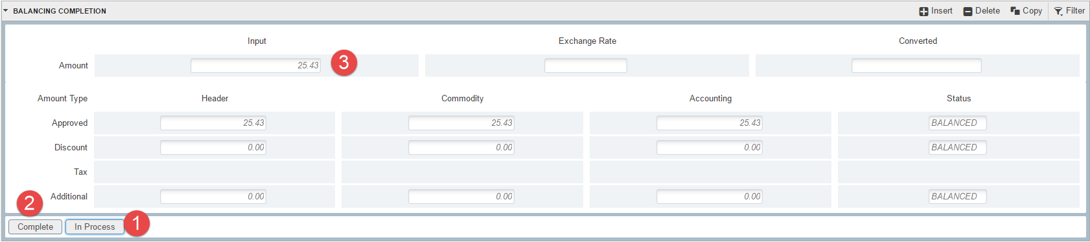

Purchase Order - FPAPURR

Enter FPAPURR in the search bar on the Welcome Page.
- Enter NEXT to let Banner choose the next available Purchase Order Number.
- If you have an old PO, you can choose copy and copy forward an old PO.
- Click the button to proceed or ALT+PG DOWN
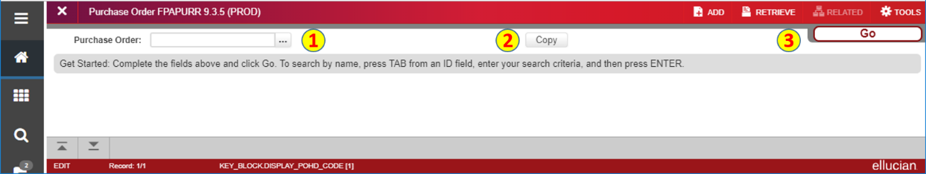
Document Information:
- This is the header section in a Purchase Order. The Purchase Order Number will be available on the next tab.
- Delivery Date is required.
- Comments can be added.
- Order Date is required and defaults to today’s date.
- Transaction Date is required and defaults to today’s date. This date can be a date in an open period in the past or future.
- Document Level Accounting: If you have multiple line items (commodity records) and each line item must be paid from a particular FOAP, then you have to assign each line item its own FOAP. If you are using multiple FOAPs and the cost can be split over the entire document, you do not have to use Document Level Accounting.
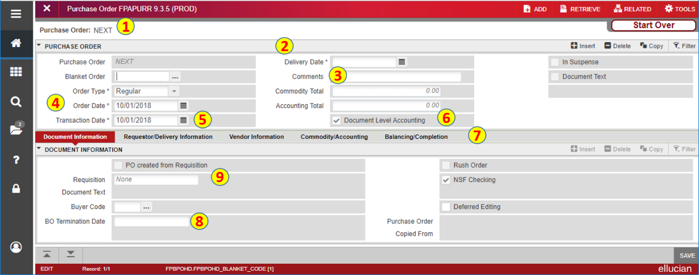

Requestor/Delivery Information
- The Header record continues through all the tabs. This can be minimized by choosing the small arrow next to Purchase Order.
- Requestor/Delivery Information defaults from the Profile Maintenance view in Banner Finance.
- Default Organization also defaults from the profile maintenance form.
- Ship To defaults from the profile maintenance window and is required.
- Attention To required should contain department contact information with name and campus phone extension.
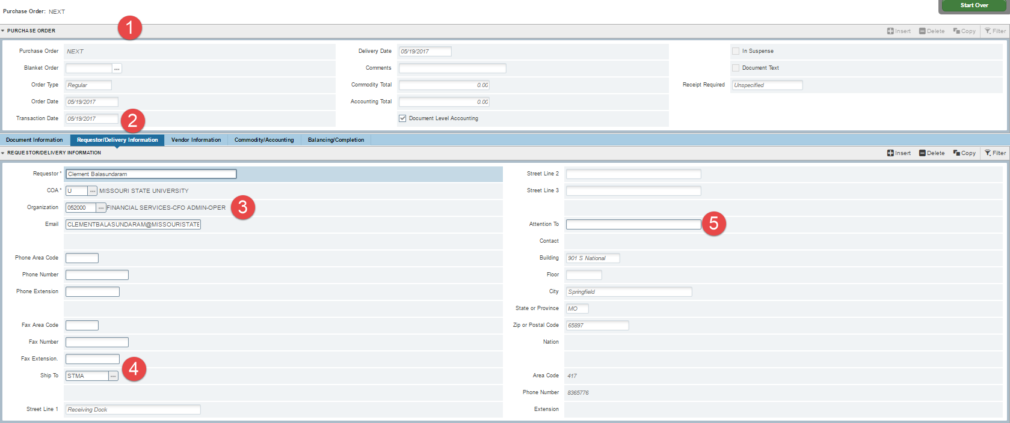
Vendor Information:
- Enter Vendor ID if it is available.
  - Click the three dots next to the field for option list below.
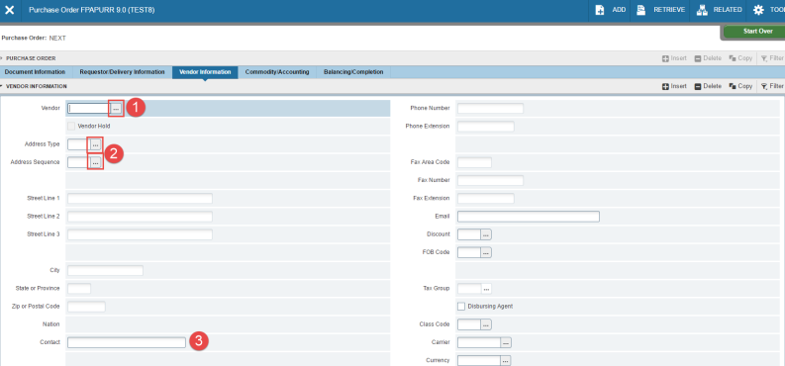
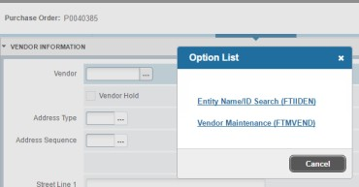
  - F9, is the shortcut key to enter into search and will take you to FTIIDEN.
- Tab and choose Address type and Address sequence number.
- Choose Next section when complete with required fields.

Commodity/Accounting
- Enter Commodity Code or use the three dots to search for valid commodity codes.
- U/M Unit of measure is required and will default to EA.
- Quantity needed is a required field.
- Unit Price is a required field.
- Check Commodity Text or Item text to add text to purchase order.
  - Add Commodity is used to add a commodity code that does not exist in the commodity table but is being used in this purchase order.
- Any Discounts that might apply.
- Additional costs.

- Insert accounting FOAP information:
- If you have NSF override authority, you will be able to override completion due to insufficient funds.
- Use the COPY function to add a new record and copy the previous record.
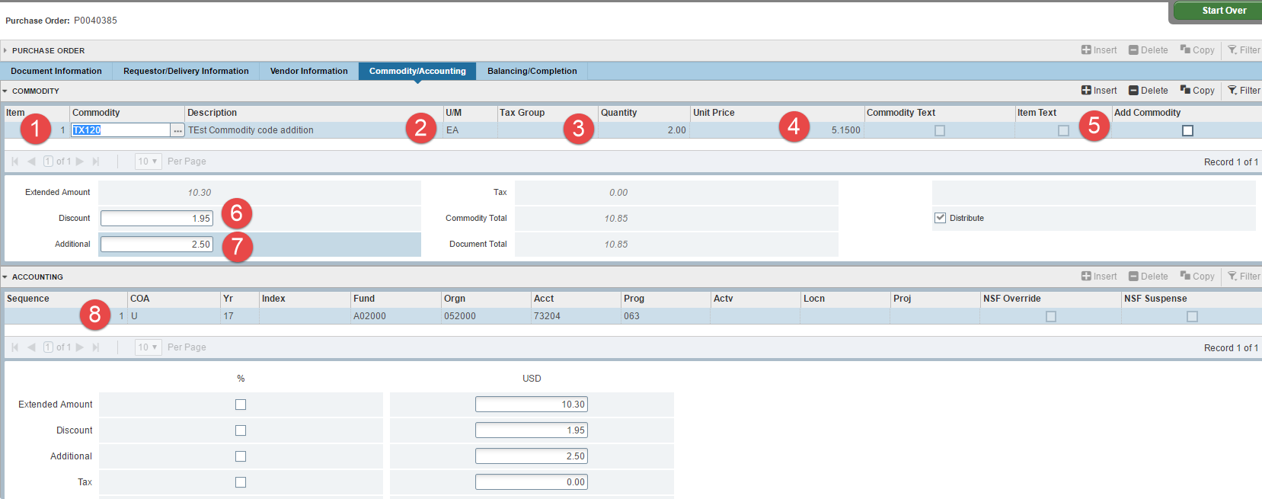

- Complete to finish the requisition.
- In Process to save the Requisition. NOTE: the money is encumbering funds without being completed and will show as a pending document on FGIBAVL.
- No Receipt Required is also required.
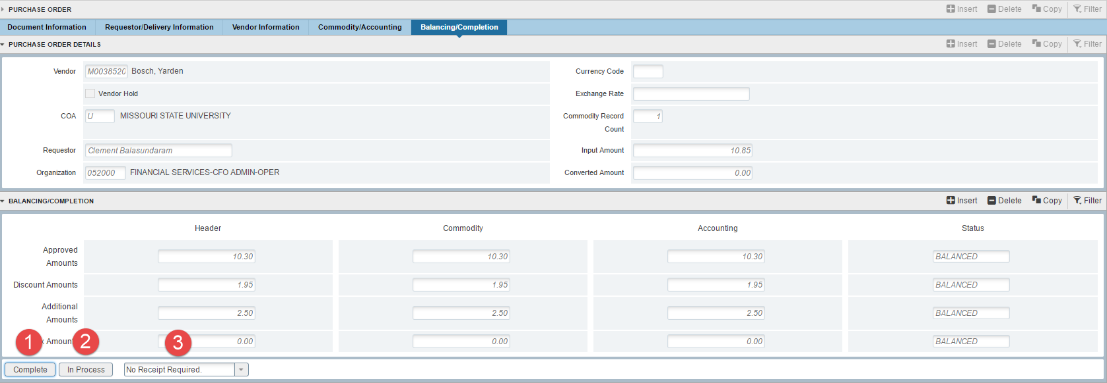
Once Document has completed the following message will follow. Purchase order has to go through the Approval Process and Posting process to post to the ledger.

Error messages in Banner 9 display in three different colors on the top right of the screen.
Red Error requires changes to the form before proceeding.
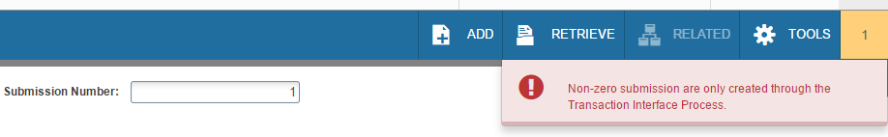

Green messages are informational and do not need any changes to the form.
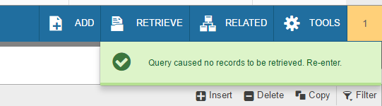

Yellow Messages require action.
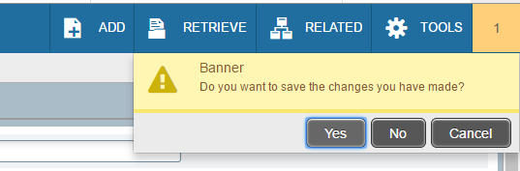

Resources for Help

Email:
financesecurity@njit.edu

Helpful Webpages:

Rule Codes:
Common rule codes you might see in Banner Finance forms:
PORD - Establish purchase order
INNI - Accounts payable invoice without encumbrance INEI - Invoice with encumbrance
INEC - Credit memo with encumbrance a Purchase Order DNNI - Check - invoice without encumbrance
DNEI - Check - invoice with encumbrance BD04 - Budget transfer done by end user
UB04 – Budget Adjustment by Financial Services
JE16 – Journal Entry by Financial Services (Inter Fund) JE15 – Journal Entry by Financial Services (Intra Fund) REQP - Requisition – reservation
RCQP - Cancel requisition PORD - Establish purchase order
POLQ - Purchase order - request liquidation PCLQ - Cancel PO - reinstate request
Invoice Transactions:
INNI - Accounts payable invoice without encumbrance INNC - Credit memo without encumbrance
ICNI - Cancel invoice without encumbrance ICNC - Cancel credit memo without encumbrance ICEI - Cancel invoice with encumbrance
ICEC - Cancel credit memo with encumbrance DNNC - Check - C/M without encumbrance DNEC - Check - C/M with encumbrance
CNNI - Cancel check - invoice without encumbrance CNNC - Cancel check - C/M without encumbrance CNEI - Cancel check - invoice with encumbrance CNEC - Cancel check - C/M with encumbrance BD01 - Permanent adopted budget
BD02 - Permanent budget adjustments BD04 - Temporary budget adjustment GRAR – Accrued Accounts Receivable GRRV - Accrued revenue
GRCC - Cost share charge GRCG - Cost share grant GRIC - Indirect cost charge GRIR - Indirect cost recovery
JE16 - General Journal Entry (Inter Fund) JE15 - General Journal Entry (Intra-fund)

