Guidelines for Course Evaluation System

# Summary

* Since Fall 2014, NJIT uses Explorance Blue, the leading course evaluation software. The course evaluations are run in the Fall and Spring semesters.
* All course evaluations are to be completed online, via a portal provided through, and integrated with, NJIT’s online systems. This portal will be ‘friendly’ to a wide range of devices, including tablets and smartphones.
* Access to the evaluations is now available through any of the following methods: 1) link provided in the e-mail from NJIT Survey, 2) Canvas: <https://canvas.njit.edu/> , or 4) *NJIT GO* smartphone application (available as a free download through the [Apple App](https://www.apple.com/ios/app-store/) Store and the [Google Play store](https://play.google.com/store/apps/details?id=edu.njit.elluciango&hl=en)). For any of these methods, authentication at the Login Service screen will require your UCID and password.
* The course evaluation will run in two phases:

**Phase 1: Elective opening (instructor choice—for a limited time or all of phase 1).**

**Phase 2: Conditional automatic opening.**

* Prior to start of the course evaluation period, instructors will receive an email that they have the *option* to schedule evaluations **for a limited time or all of phase 1.** (Note that if you do not schedule evaluations for your courses, students will not be able to access the evaluation until Phase 2.) If an 80% or higher response rate is achieved, the evaluation for the course will close (see Timing section).
* If an instructor does not schedule evaluations during the Phase 1, or does schedule them but does not receive a sufficient response rate, the evaluations will be automatically opened in Phase 2.
* The best ways for faculty and students to access the course evaluation system are:

— By computer/laptop: Canvas: <https://canvas.njit.edu/>

— By smartphone/device: *NJIT GO*

For either method, authentication is required (UCID and UCID password).

* Instructors will be able to see the response rate in real time using any of the following: 1) a hotlink in an e-mail that you will receive from NJIT Survey, 2) Canvas: <https://canvas.njit.edu/> , or 3) the *NJIT GO* smartphone application. **Be sure to save the email from NJIT Survey in case you have any questions.**
* Students will have the opportunity to submit their evaluations, or to save (and not submit). Students can return to their saved evaluations at any time to amend or extend their responses. Once an evaluation is started, it will remain open until it is submitted, or until the end of the evaluation period is reached.
* The course evaluation consists of 11 ratings questions and 3 open-ended comment questions. It should take about 5-10 minutes to complete. For sections with multiple listed instructors, a student will see a single set of questions concerning the course, and then have the opportunity to evaluate each instructor separately.

## Timing

The course evaluation will run in two phases:

**Phase 1: Elective opening (instructor choice--** *option* to schedule evaluations **for a limited time or all of Phase 1).**

During the Phase 1 of the overall evaluation period Phase 1, the evaluation system for a given course will be closed unless opened by the instructor for that course. The start and period of opening is under the control of the instructor, and can be as short as desired, for example, to cover the meeting time of a single course. There can be more than one open period. This will allow an instructor to hold evaluations during course (or courses). But, **note that an instructor does not *have* to host course evaluations** — they may simply choose to open the evaluation system for out-of-course completion.

Please inform your students when you will be conducting the course evaluation. You can schedule your own course evaluation and view response rates in real time using any of the following: 1) a hotlink in an e-mail that you will receive from NJIT Survey, 2) Canvas: <https://canvas.njit.edu/> , or 3) the *NJIT GO* smartphone application. For detailed instructions, see the section on Instructor Guide to Scheduling Your Course Evaluations later in this document.  **Please save the email from NJIT Survey as a reference.**

If you decide to conduct the course evaluation during any portion of Phase 1, please notify your students. The students can access the course evaluation through Canvas: <https://canvas.njit.edu/> or through the *NJIT GO* application on their smartphones.

After authentication, students will see a list of the courses that are scheduled by you or other instructor(s).   Authentication will require their UCID and password. Advise students to contact the IST Help Desk at (973) 596-2900 if they have a problem accessing the course evaluation.

**Any instructor** can schedule the course evaluation for all or any portion of the Phase 1 week through: 1) the hotlink in the email from NJIT Survey, or Canvas: <https://canvas.njit.edu/> ,or through the *NJIT GO* application

**Phase 2: Conditional automatic opening.**

What happens during the second evaluation period is conditional upon what happened during the previous, elective opening period:

* If, at the end of the first phase of evaluations, the response rate meets or exceeds a threshold (currently set at 80%), the evaluation system for that course will close, and no further evaluations will be possible.
* If the response rate does not meet the 80% threshold, or if the evaluation system was not opened at all by the instructor, then it will open automatically and will stay open for the remainder of the evaluation period.
* For every course that is open during the Phase 2 period, students in that course who have not yet completed an evaluation will receive automated e-mails requesting them to do so. There will be three automatic e-mails, and then possibly more initiated by the system administrator depending on response rates.
* **Faculty can still urge students to complete the course evaluation during this period if they choose to do so. However, faculty will not be able to use the scheduling function.**
* Students can access the system through: 1) the hotlink in the e-mail from NJIT Survey, 2) Canvas: <https://canvas.njit.edu/> or 3) the *NJIT GO* application. Authentication will require the students to enter their UCID and password.
* The evaluation system for all open courses will close on the **last day of the course evaluation period.**
* Faculty will be able to monitor the response rate for each course during the entire evaluation period. **Be sure to save the email from NJIT Survey as a reference.**

**SAMPLE EMAIL**

**Suggested Email Text for Faculty Email Notice to Students for course evaluation:**

Your input does make a difference!  It is important that as many students as possible complete the course evaluation. Your feedback is used to help the university improve learning at NJIT.

[Date, day, and time that you will be conducting the course evaluation and date, day and time the evaluation will close]

Please complete it during this time frame. You can complete the course evaluation using Canvas: <https://canvas.njit.edu/>. You can also use a smartphone to complete the course evaluations if you have the *NJIT GO App* installed. Authentication will require your UCID and password. If you have a login issue, contact the IST Help Desk at (973) 596-2900Thank you for your cooperation.

Sincerely,

# Faculty Responsibilities

All instructors **are expected to**:

1. Make every effort to ensure that as many students as possible get the opportunity to evaluate a course, regardless of academic performance.
2. Be familiar with how to e-mail your students by using Campus Pipeline or Canvas.
3. Have an activated UCID. If you do not, you cannot access the course evaluation system.

Instructors who elect to schedule course evaluations **must**:

1. Announce the timing of the course evaluation period or periods in plenty of time.
2. Tell students if this will be the only opportunity to do evaluations (assuming the threshold response is achieved).
3. Instructors can also suggest that students download the *NJIT GO* application from the [Apple App Store](https://www.apple.com/ios/app-store/)  or the [Google Play store](https://play.google.com/store/apps/details?id=edu.njit.elluciango&hl=en) in advance of the scheduled evaluation period.
4. Remind any non-NJIT students (most likely Rutgers) that they will need to be able to log in to the NJIT online system (Canvas) to complete an evaluation. Non-NJIT students must have an activated NJIT UCID. To get an UCID, they need to contact the IST Help Desk at (973) 596-2900 or visit <https://ist.njit.edu/ucid>
5. Instructor who elect not to schedule an course evaluation in Phase 1 **must**:

announce the beginning of the open evaluation period, and encourage students to complete the evaluation on their own time.

Instructors **must not** loan any student a personal or instructor-controlled device (e.g., a laptop) on which to complete an evaluation, as this compromises confidentiality. Instructors can make arrangements for students to use NJIT public computing facilities if necessary.

# Instructor guide to scheduling your course evaluation

**Step 1:**

At the beginning of the evaluation period, instructors will be sent an email from NJIT Survey that contains a link to the online system. **Be sure to save the email from NJIT Survey.**

**Sample message:**

The NJIT Course evaluation will be run in 2 Phases.

Phase 1-Faculty has the option to conduct the course evaluation for their course from November 1xth –November 2xnd. The online course evaluations can be accessed 24/7 from any location via the internet by computer or any mobile device.

Please inform your students when you will be conducting the course evaluation. You can schedule your own course evaluation and view response rates using the following link. [Please click here to manage your courses and view response rates.](http://www.explorance.com) Course evaluations can also be scheduled through the *NJIT GO* smartphone application.  
  
If you decide to conduct the course evaluation during any portion of PHASE 1, please notify your students.

The students can access the course evaluation at the following links:

Canvas: <https://canvas.njit.edu/> or using the *NJIT GO* smartphone application.

The course evaluation system will list the courses that are scheduled by you or other instructor(s).   Authentication will require their UCID and password. Advise students to contact the IST Help Desk at (973) 596-2900 if they have a problem accessing the course evaluation.

Any instructor can schedule the course evaluation for all or any portion of this period by using this link: [Please click here to manage your courses and view response rates.](http://www.explorance.com)

Or you can wait for Phase 2-Starting November 2xrd to midnight December 1xth; the course evaluation will be released for all courses that did not meet the target response rate of 80%. Students will receive an email on November 2xrd with a link that will allow them to access to all their course evaluations.

**Note: Please save this email to ensure that you can continue to monitor your response rate during Phase 1 and Phase 2.**

If you have any issues, please contact the IST Help Desk at (973) 596-2900.

Alternatively, instructors can use the *NJIT GO* smartphone application to schedule course evaluations during Phase 1. Once logged into *NJIT GO*, instructors can select Course Evaluations from the main menu to schedule their evaluations.

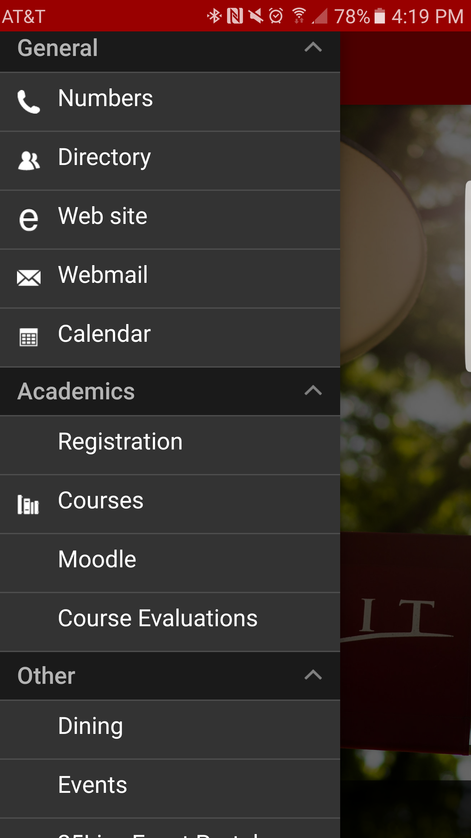

After selecting Course Evaluations, the following screen appears. To schedule or manage course evaluations, instructors should select Dashboard from the My Space menu.

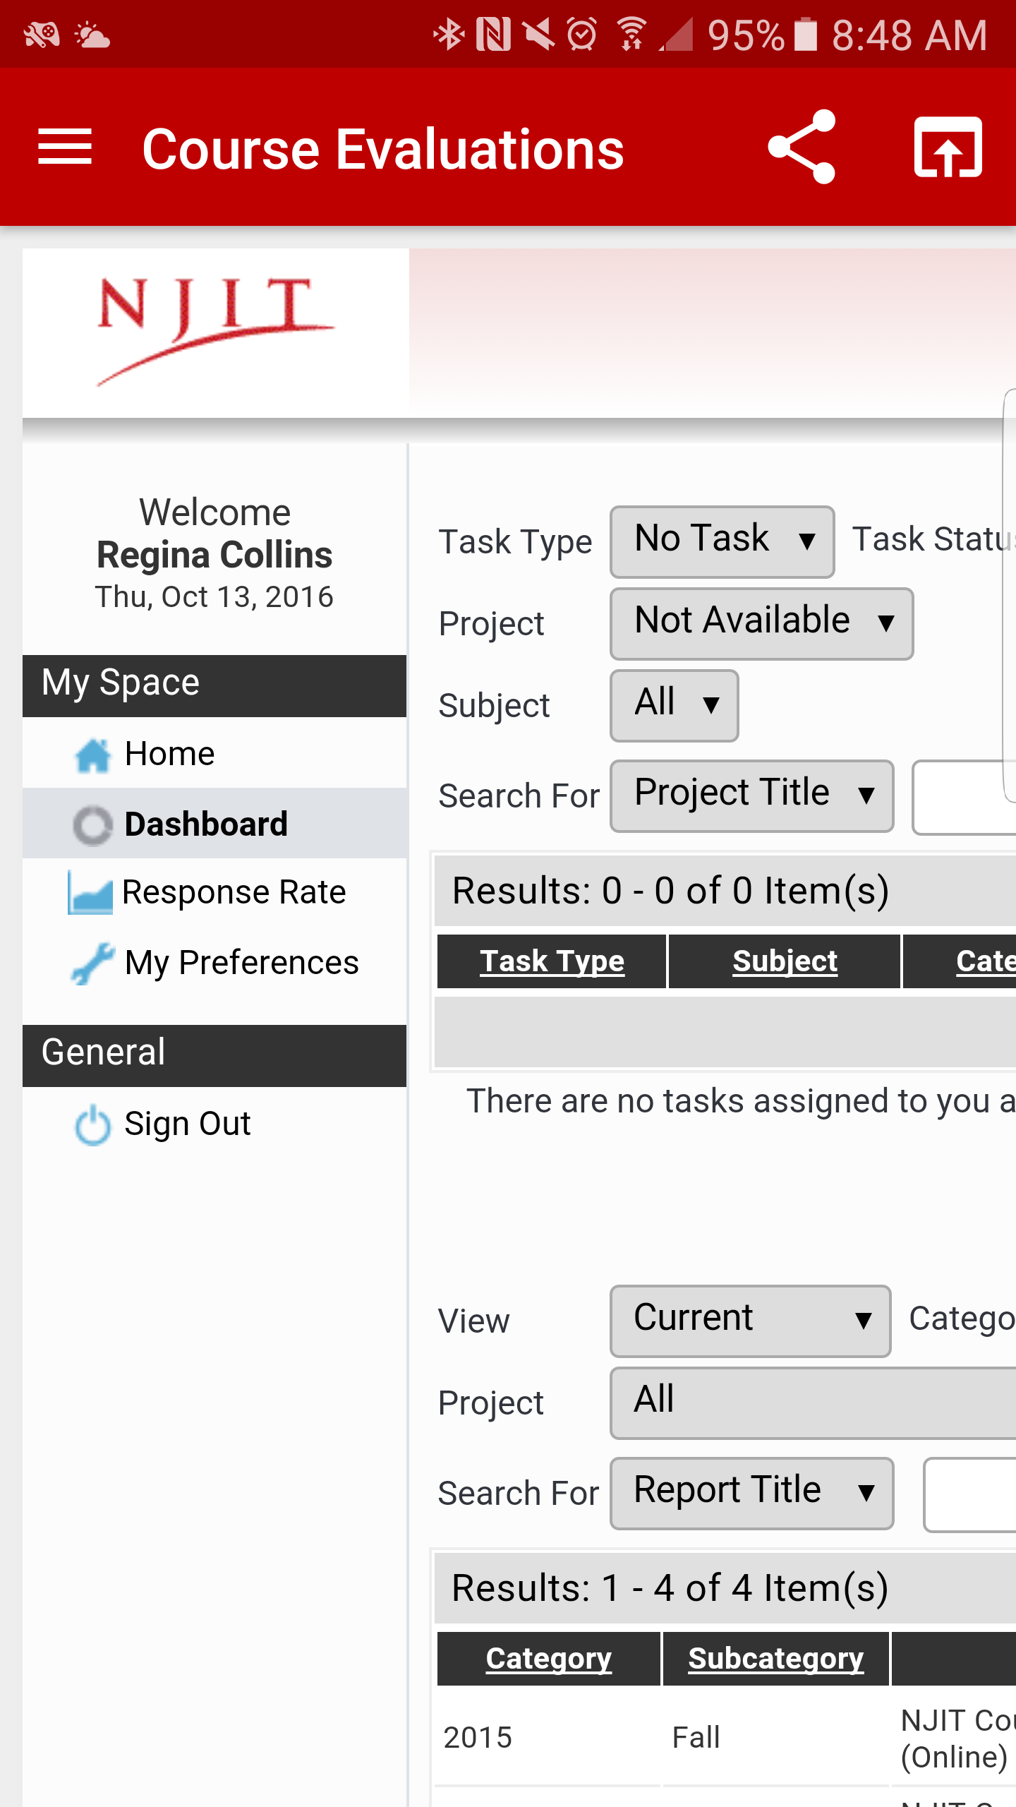

**From this point on, regardless of whether instructors use the link provided in the NJIT Survey e-mail or the *NJIT GO* application, the steps for scheduling evaluations as outlined below are the same.**

**Step 2:**

Instructors will each see a list of the respective courses they teach. Click either **Select** or the **Course Name** link to access the evaluation start/stop controls for that course:

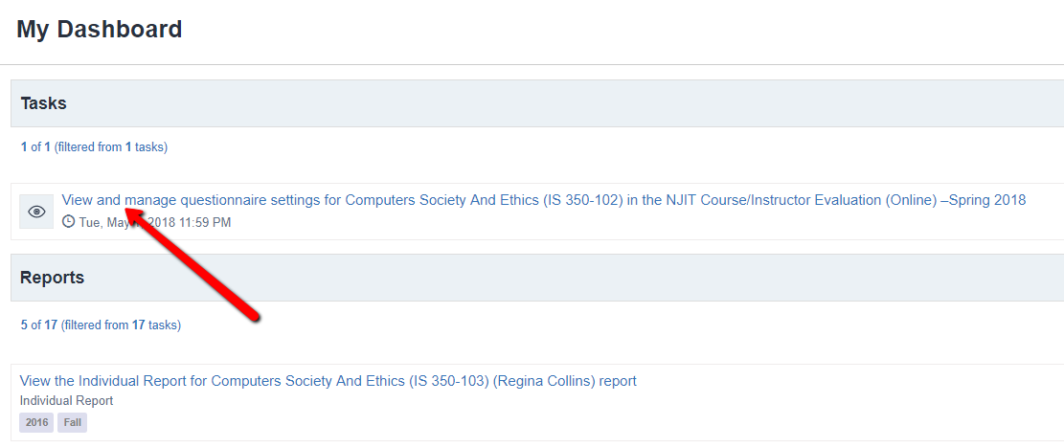

**Step 3:**

Clicking the link will allow faculty to select their Phase 1 course evaluation schedule.

1. Click the calendar icon next to the **Start** time to set your own date and time (using a 24-hour clock with values shown below) for when you want the evaluation to open.

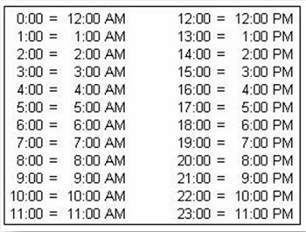

1. Do the same for the **End** date and time.
2. Click **Apply Changes** when you are done.

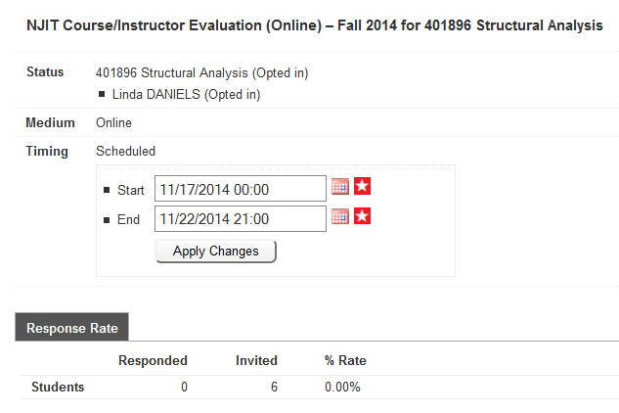

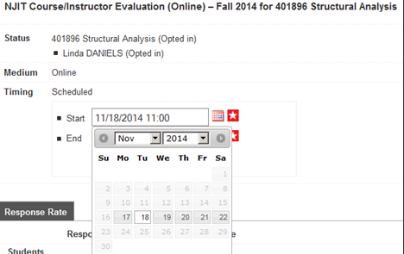

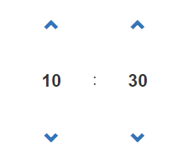

Set time (Military) Hour Minutes

Confirmation that your changes have been saved:

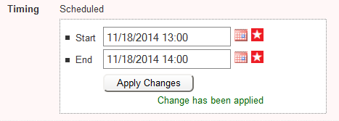

Mouse over the star icon to see the period during which the start and end dates can respectively be set:

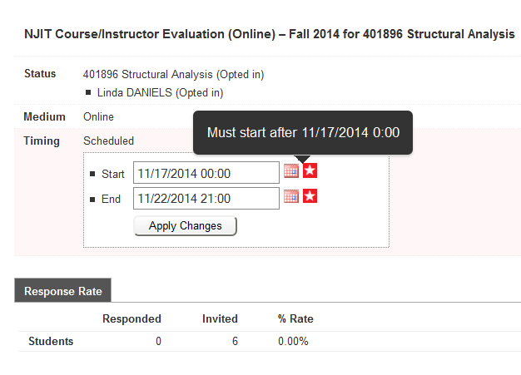

**NOTE: The above scheduling feature is only available for the first period of the evaluation.**

# Instructor guide to monitoring your course evaluation

Instructors can monitor the response rate during all phases of the course evaluation by clicking on the Response Rate tab on their computer or laptop.



If accessed through *NJIT GO*, instructors should select the Response Rate menu item.

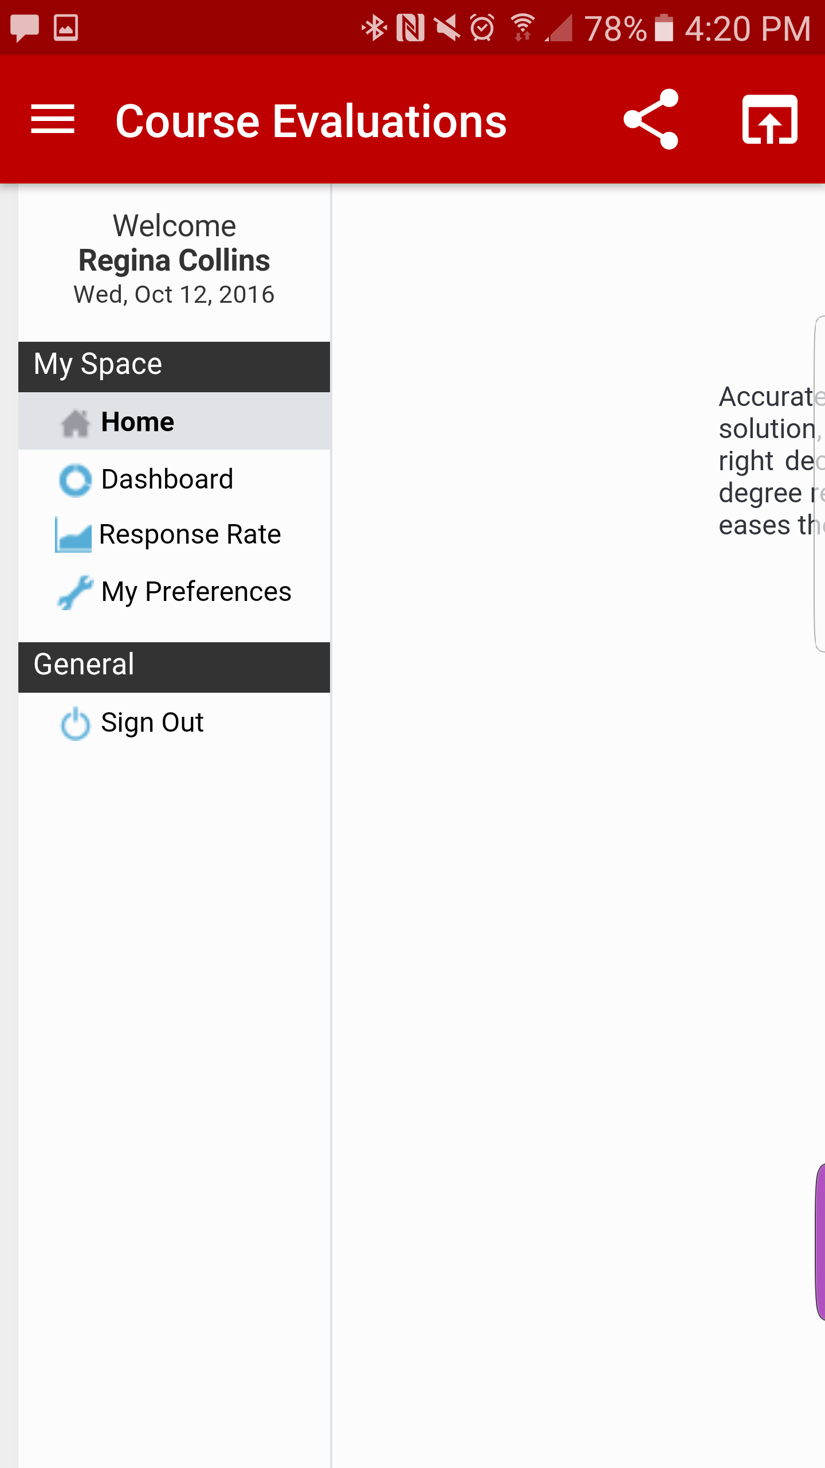

Use the  symbol to refresh the information for live, up-to-date responses:

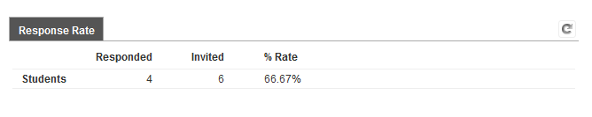

Check Response rates using Canvas

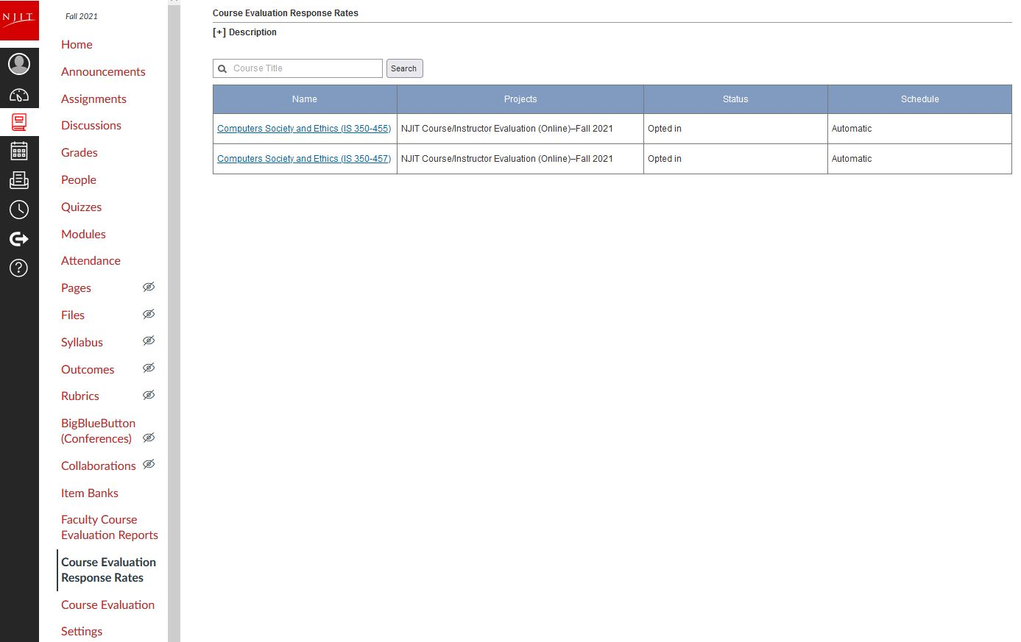

Click on Course Evaluation Response Rates, then click on course title

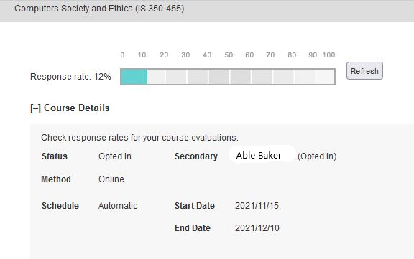

# Student Responsibilities

All students **are expected to**:

1. Have an activated UCID. If not, advise them contact the IST Help Desk at (973) 596-2900 OR visit <https://ist.njit.edu/ucid>.
2. Complete a course evaluation unless there is a compelling reason not to do so.
3. Complete course evaluations fairly and constructively.

# Accessing Your Course Evaluation Reports

About 2 weeks after final grades have been released to the students, faculty will receive an email(s) with a hotlink to the course evaluation report(s).

Reports for the current or previous semesters can be accessed through Highlander Pipeline, Canvas ([https://canvas.njit.edu](https://canvas.njit.edu/)/) or the *NJIT GO* application. Authentication is required (UCID and UCID password).

**Accessing Your Reports through Canvas**

Log in to your course in Canvas, click Faculty Evaluation CourseReportson the menu on the left side of the screen.  
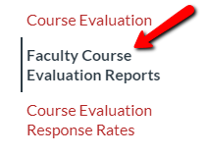

Click on the report that you want to view. If prompted for a data source, choose instructors, view report dashboard, select report(s) and download. (Look for download button).

It is best to download your report(s) to a secured drive.

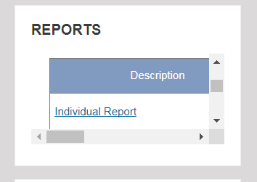

IT IS BEST TO ACCESS YOUR REPORTS USING CAMPUS PIPELINE.

**Accessing Your Reports through Highlander Pipeline**

Course evaluations can be accessed through the Faculty/Staff services block in Highlander Pipeline. This method provides simplified access to all historical course evaluations for instructors. At the NJIT home page, click on MyNJIT Login to access Highlander Pipeline using your ucid and ucid password:

1- Click on Faculty/Staff services (on left side of screen)

2- Scroll down to **Academic & Faculty Services** block, click on Course Evaluation service –by Explorance Blue (hotlink).

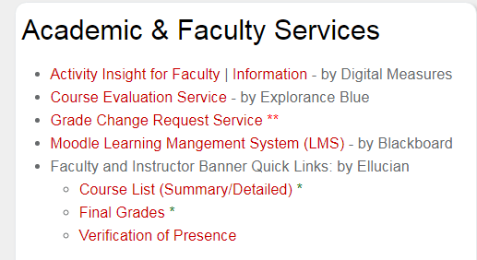

3-At the Explorance screen, when prompted for a data source, choose INSTRUCTORS.

**Method 1**

You should see all your reports. If you don’t see the report(s) you want, **turn on the show child report switch. See yellow highlight. If still don’t see all your reports** scroll down and click on view more. **See yellow highlight.**

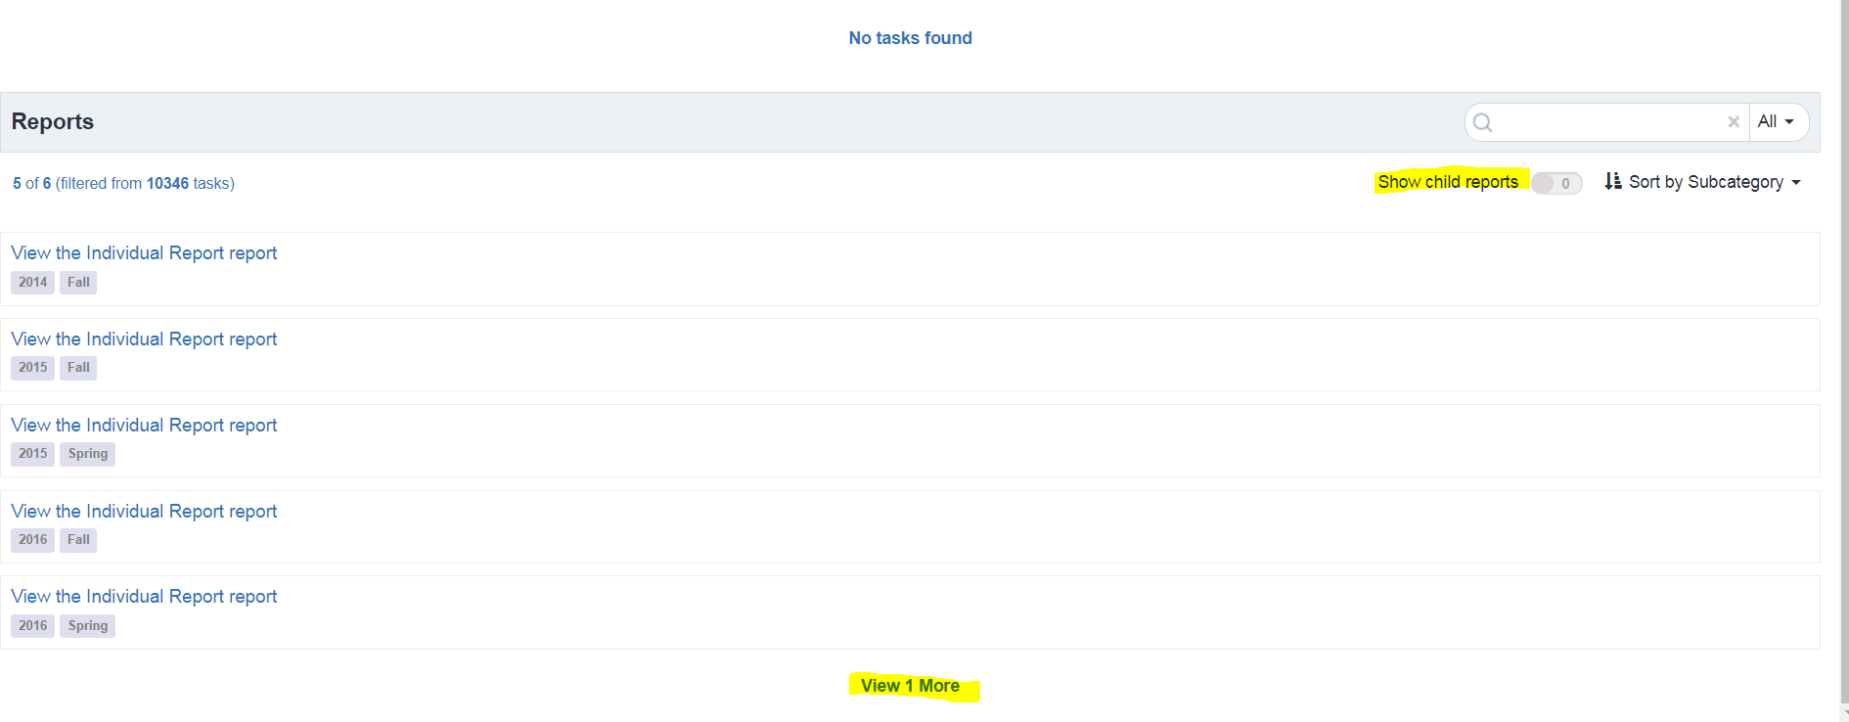

Click on the pdf icon for each report to download your report(s).

**Method 2**

If you only want to see your reports for a particular semester, type the semester and year (e.g. Spring 2017) that you want to view in the search window. Turn off show child report switch. Click on report title (e.g. View the Individual Report). View reports, select (all) report(s) and download (look for download button). Un-zip pdf.

**Accessing Your Reports through *NJIT GO***

To access existing course evaluation reports through the *NJIT GO* application, faculty should first select Course Evaluations from the main menu.

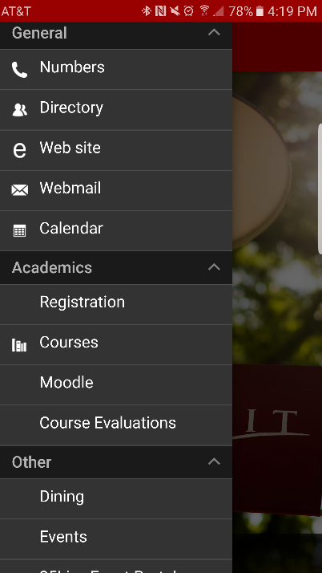

Login in using your ucid and ucid password:

At the Explorance screen, when prompted for a data source, choose INSTRUCTORS. You should see all your reports.

. 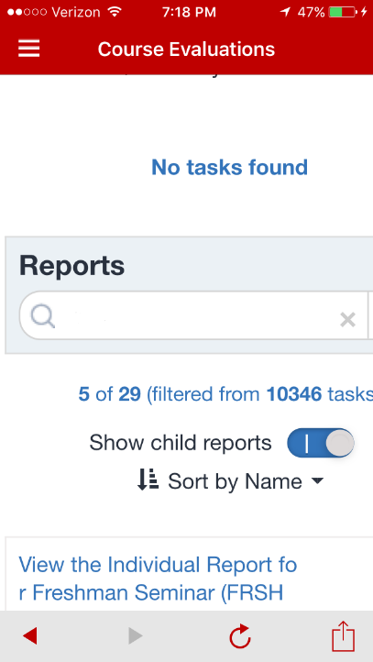

If you don’t see the report(s) you want, **turn on the show child report switch.**

By scrolling down, instructors can select the appropriate course evaluation report to view.

**If still don’t see all your reports** scroll down and click on view more.

Click on the pdf icon for each report to download your report(s).

**Issue: Cannot see the pdf reports.**

Reconfigure your browser to work with Acrobat or Reader plug-in.

Visit: <https://helpx.adobe.com/acrobat/kb/pdf-browser-plugin-configuration.html>