ApplicationXtender 16.3 User Guide
How to Search, Retrieve, & Index Documents With ApplicationXtender Web Access

Table of Contents

Chapter 1: Introduction 4
Xtender Overview of features 4
Document storage and display 4
Supported file types 5
Unsupported file types 5
Chapter 2: Getting Started - How to Access Xtender 7
How to Access Xtender from URSA 7
How to Access Xtender from Banner 8
Xtender Home Page 10
Chapter 3: How to Create/Run Queries 11
Xtender Query Overview 11
How to Create and Run a New Xtender Query 12
Methods of entering Query Search Criteria Values 13
Query Results Window 17
Chapter 4: How to Navigate Documents/Pages 19
Xtender Document - Page Toolbar 19
Thumbnail Icon – Show/Hide Thumbnails 20
Page Navigation Icon 20
Chapter 5: How to Create a New Document 25
How to Import a New Documents – Toolbar Method 26
How to Import a New Documents - Click and Drag Method 27
IHow to Create New Documents with a Scanner 28
How to Set up Your Scanner 28
How to Scan a Document 31
How to Index a Document 32
Indexing Window 33
Indexing Navigation, Rules and Tips 33
Chapter 6: How to Create a New Batch 36
Creating a New Batch – Steps: 37
Chapter 7: How to Manage Batches 38
How to Index a Batch 39
How to Edit a Batch 39
How to Import a Batch 40
Chapter 8: How to Use Xtender Annotations 41
Annotation Types: 42
How to Modifying/Edit Annotations 47
How to Delete Individual Annotations 48
How to delete all Annotations for a document 49
How to Hide Annotations 49
Appendix A: User Settings 49-51

Chapter 1

Introduction

ApplicationXtender is the University’s document imaging system. ApplicationXtender version 16.3, hereafter referred to as “Xtender”, enables users to query, create, index, and annotate electronic documents in a variety of formats for subsequent retrieval via the university’s URSA web portal.

Xtender Overview of features
- Scan documents to create new or add to existing documents or batches. Scanning in Xtender
16.3 requires the installation of the “Captiva Cloud Toolkit” software. To have this software installed on your computer, submit a ticket with the Technical Support Center.
- Add/import electronic files to the Xtender as individual documents, batches, and individual pages. As you will see, Xtender 16.3 allows you to “click and drag” files from your local file system into the Xtender document import window.
- Index documents by specifying information in the application-specific index fields. Indexing enables you to organize, search, and retrieve documents efficiently.
- Retrieve documents through queries by using various search methods.
- Attach annotations or redactions to highlight important information, comment on the contents of the page, or block areas of the page from view.

Document storage and display
You can store any type of file in Xtender. However, depending on the type, Xtender stores files as supported or unsupported file types. Features that are available with one file type might not be available in another. Also, supported and unsupported files types are displayed in different ways.

Supported file types
Supported files are defined as those file types that Xtender can display within the Xtender Web Access window. The following file types are supported:
- Text files (TXT)
- Image files (JPEG, GIF, TIFF, Windows Bitmap, PCX, DCX, and TGA)
- Adobe Portable Document Format (PDF) files.
- Rich Text Format (RTF) files
- Hypertext Markup Language (HTML) files
- Extensible Markup Language (XML) files

Unsupported-Foreign file types
Unsupported file types are those that can be imported into Xtender, but can’t be displayed in the Xtender Web Access viewer. Example of foreign files include Excel spreadsheet files; MS-Word documents, PowerPoint files and others.

Foreign files stored in Xtender can be viewed in one of two ways:
- Download the foreign file. This option will display the foreign file within the application associated with the file type. For example, an Excel file will display within MS-Excel; Word documents will display in MS-Word and so on.
- Render the foreign file. This option will attempt to display the contents within your web browser.

When you hover over the thumbnail of a foreign file in the query results screen, the document thumbnail will reveal that the document is a foreign file:

When a foreign file is opened in Xtender, it will provide the following options for display:

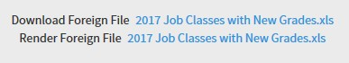

Clicking the “Download Foreign File” option will enable you to display the contents of the file in the native application associated with the file type. For example, a file with a “.xls” file extension will display in Microsoft Excel; files with a “.docx” extension will display in Microsoft Word and so on.

Clicking the “Render Foreign File” option will result in the file/document content displaying in your web browser window. Both display options are acceptable if the intention is just to view the document content, but the native application option such as Microsoft Excel provides more options.

Chapter 2

Getting Started - How to Access Xtender
There are 2 ways to access Xtender:
- From the University Web Portal URSA menu.
- From Banner.
Both access methods require an Xtender profile, which can be granted by the Technical Support Center.

How to Access Xtender from URSA
Once you have logged into URSA, Xtender can be accessed from the Employee tab and General Information column, as shown below. Xtender access requires a security profile specific to Xtender. Contact the Technical Support Center if you need to have an Xtender profile created.
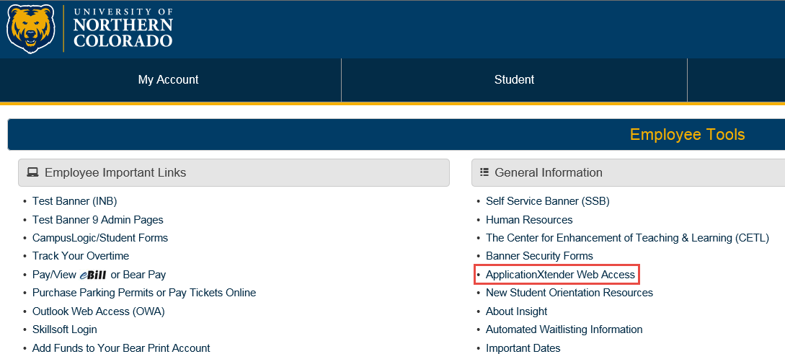

How to Access Xtender from Banner
Access of Xtender from Banner enables you to view or index documents based on the content of the Banner form you are positioned on. For Banner pages that are Xtender-enabled, Xtender can be accessed by selecting one of the “Banner Document Management” options under the Tools menu, as shown below:
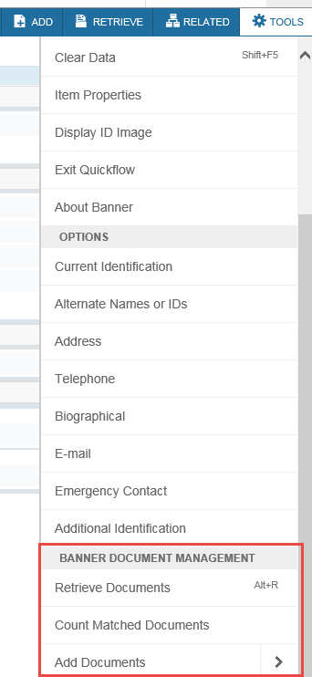

Banner – Xtender Access Items of Note:
Xtender access from a Banner 9 Admin Page enables you to view or index Xtender documents that share related key information such as a Bear# (Student applications) or Document number (Finance applications.) But, note the following when navigating within the Banner system and attempting to access Xtender documents:
- Not all Banner 9 pages are configured for Xtender access. If you don’t see the Banner
Document Management heading under the Tools menu, which indicates the Banner form is not linked to Xtender.

- The Xtender document/page that will launch from a Banner 9 form depends on where your cursor is placed on the page.

- Some Xtender content is filtered or restricted based on content. When viewing or indexing documents in Xtender, be aware that Xtender security may determine what documents you can view based on one of the 3 additional layers of security:

  - Document level security. Some Xtender applications restrict what document types can be viewed or indexed. If you attempt to view a document from Banner and don’t have the necessary document security, no documents will display.

  - Org security. The B-H-EMPL application, which contains documents related to the
Human Resources Banner module, is restricted by Org codes. All Org security utilized by Xtender is maintained in the Human Resource module of the University Banner system. If you have questions related to Org Security, please contact the University Payroll department.

  - Fund/Org security. Finance applications in Xtender like B-F-DOCS, also have a security layer of Fund/Org codes. As with Org Security, all Fund/Org security is
maintained in the Banner Finance module of the University Banner system. If you have questions related to your fund/org access, please contact Financial Services.

Xtender Welcome Page

Once you have connected to Xtender either from URSA or a Banner 9 page, you will be taken to the Xtender Welcome page. This page provides the entry point into Xtender processing. The Applications column will display all Xtender applications you have access to via a click of the Application you wish to process. Whatever application(s) you see when you launch Xtender, the navigation technique will be the same
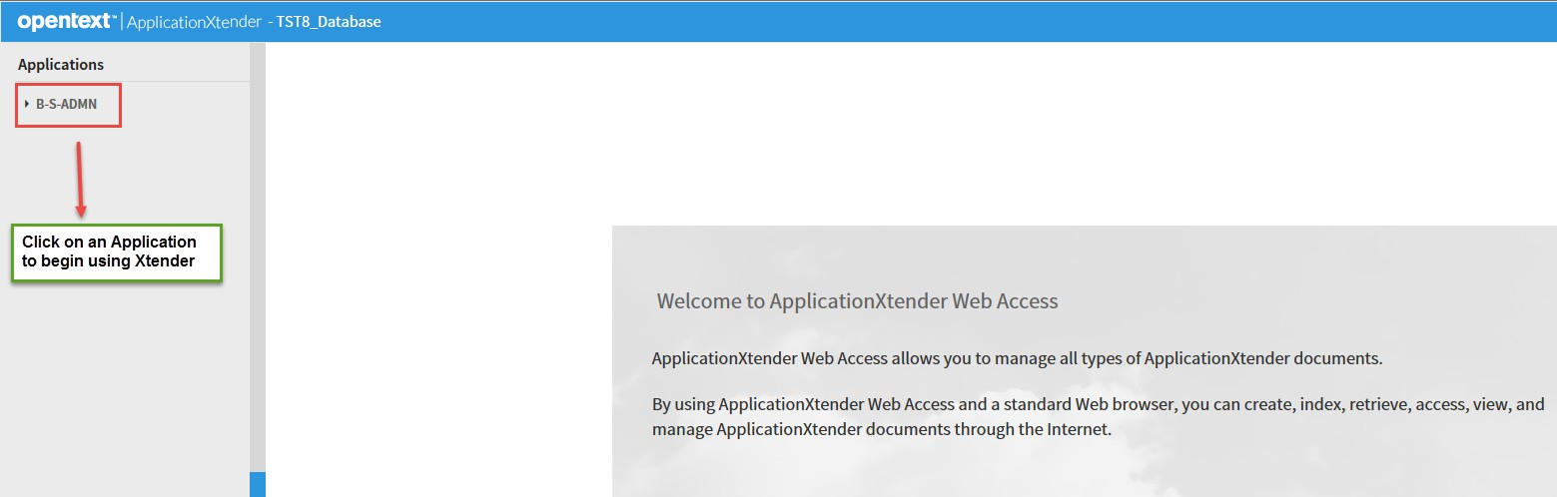

Xtender Home Page

To begin Xtender navigation to a specific application, click on the application name of the left side of the Xtender Welcome page. Clicking on any Xtender application will take you to the Xtender Home page,
where you can run queries, create new documents, or create/manage batches:
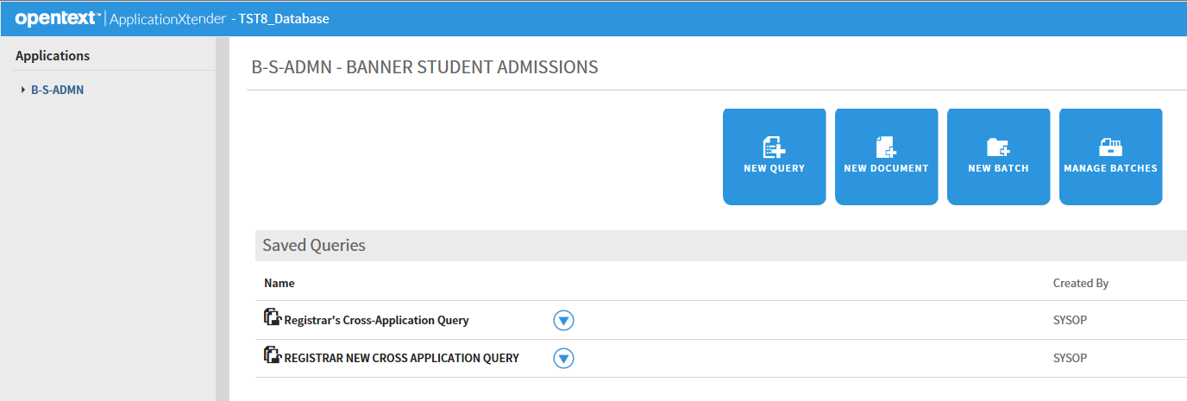

Each of the 4 Home Page actions shown above will be covered in the following chapters – How to
Create/Run Queries (Chapter 3,) How to Create a New Document (Chapter 5,) How to Create a New Batch (Chapter 6,) and How to Manage Batches (Chapter 7.)

Chapter 3

How to Create/Run Queries

Xtender Query Overview

Xtender provides a variety of document search and retrieval methods. Documents can be searched by index, wildcard, a list of values and a combination search. You can search either one application or across multiple applications simultaneously. The Xtender query tool enables you to create a new query, edit an existing query, or run an already created query. After a query is created, it can be saved for later use. Saved queries appear under the application to which they belong.

After you retrieve a document from a query, you can view, print, annotate, add and delete pages or documents, and modify index and document properties.

Clicking on the “New Query” option will produce an option to query Xtender for the selected application and show query fields that are unique to each application. In the example below, the primary search criteria for documents is the Bear# (ID.)

How to Create and Run a New Xtender Query

Xtender queries can be created and run in 3 simple steps:

- From the list of applications, select the required application and Click New Query.

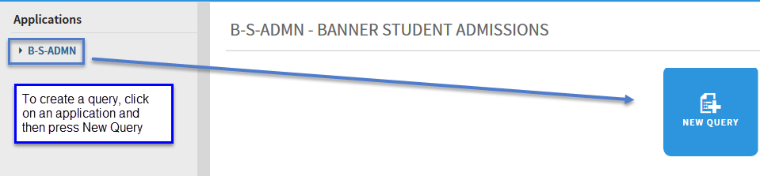

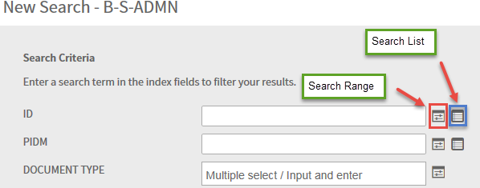
- In the New Search page, specify the search criteria by using the index fields. Queries can be created by entering one or more values in any of the search fields. The more index values you enter for a query, the narrower the search and number of documents that will be returned.

After all Query Selection Criteria has been entered, perform one of the following actions:

Click RUN to run the query without saving it for future use.

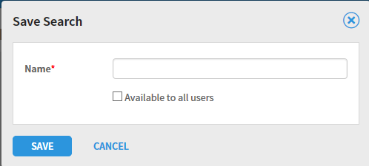
Click SAVE to be able to run the query at any time. If the query is being saved, give the query a name and optionally check the “Available to all users” checkbox if you want to share the query with other users. If you do not check that checkbox, your query is considered a private query that only you and users with the Administrator privilege can access.

Methods of entering Query Search Criteria Values

Xtender offers a sophisticated range of options for selecting search criteria. The search criteria can be as simple as one field value (like a Student ID,) or a complex combination of multiple values. This section describes the different methods of entering your search criteria.

- Single value search criteria. Query search criteria can be as simple as a single value entered in a search field. In the ID field, for example, you could enter a specific student’s Bear# to see all documents in an application for a specific student.

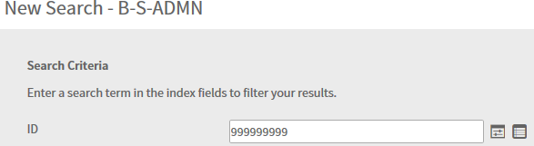

Xtender Search Criteria Tip: Wildcard character in search fields
In the New Search page, index search criteria can be specified by using the asterisk (wildcard) character in at least one field. For example, specify 2018* to search for documents with a term code that begins with the characters “2018.”

- Multiple select/Input and enter Search Criteria – for search fields that are tied to a predefined list of values (like Document Type,) you can enter values by clicking in the field and entering one or more values.

In the example below, clicking in the Document Type field produced a list of values to select from. This search criteria entry method lets you select one or more values from the list of values:
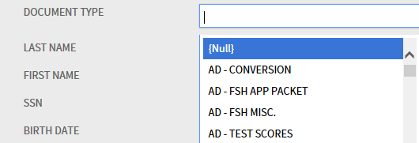

Once you have finished selecting the multiple select values, the search criteria for that field will show the selected list of values as in the example below.
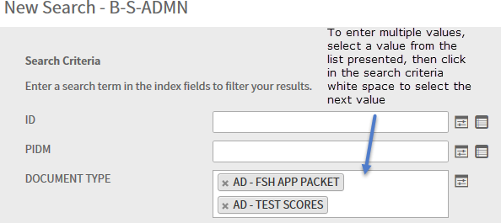

- Search Range Search Criteria – to search based on a range of values, select the Search
Range icon. That range would be entered as follows when clicking on the Search Range icon next to the term code field:

After clicking on the Search Range icon, you will be prompted to enter your beginning and ending values. Note that your “Type of Comparison” can use a number of relational operators, as shown below:
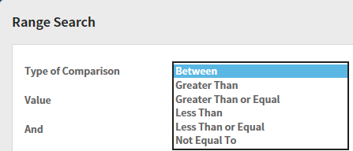

In the example below, the query will search for all documents in B-S-ADMN with a term code between 201750 and 201840.
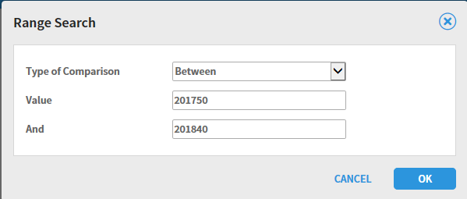

When you click OK, you’ll see the range of values displayed as an Expression in the TERM CODE search criteria like shown below:

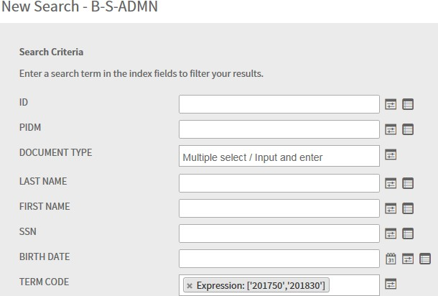

- Search List Search Criteria - this search criteria allows you to enter multiple select values for a query. As an example, if you wanted to query on 2 or more Bear#’s, you would click on the List search icon and one-by-one, enter the Bear#’s for your query. To use this query select method, click on the Search List icon next to a search field:
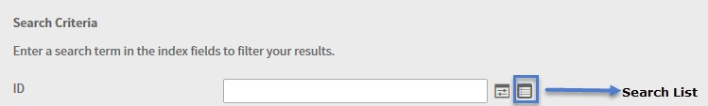

As shown below, you can enter multiple field values followed by pressing the ADD button to build your list of search values:
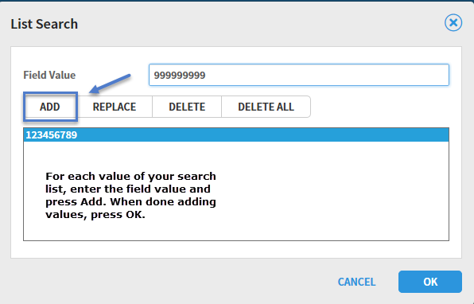

When you click OK, your List Search values will show in the Query criteria as in the following example:
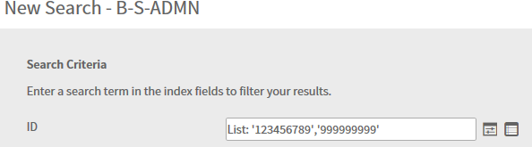

Query Results Window
When you submit a query, one or more rows of query results will display in the Xtender Query Results window as shown in the example below. To open a document, click on the down-arrow as shown and select the Open item from the menu. See Chapter 4 for Document Navigation.
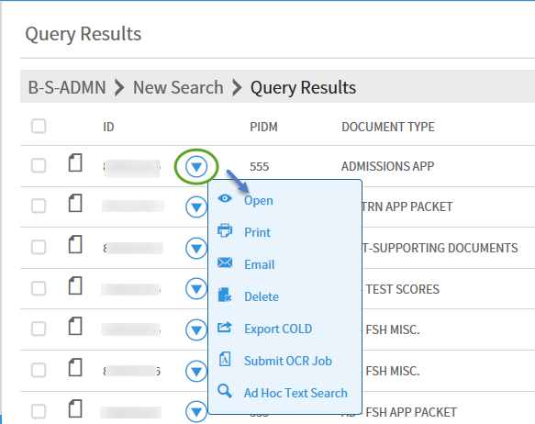

As shown on the prior screen, you have a variety of actions that can be performed on any document shown in the Query Results window. Of the options shown, the Document Open, Print and Delete options are supported and covered in this User Guide.

Open Document Results and Options
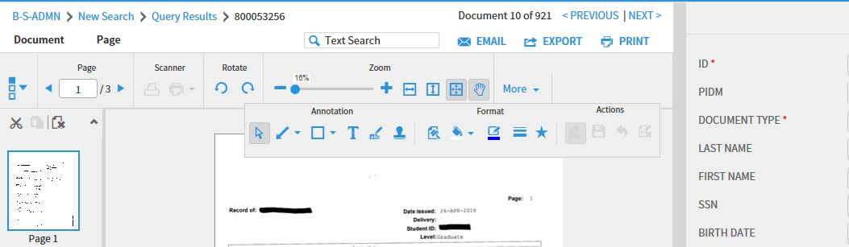

When you select the Open document option, the selected document will display with the options of adding annotations, modifying the indices, rearranging pages, or printing the page(s). Note that as shown below, you have a second method of printing a document after performing any additional tasks like adding annotations. Note as well that your options presented on documents from a query may vary depending on your Xtender security profile.

Alternative method of printing a Document in the Query Results Window
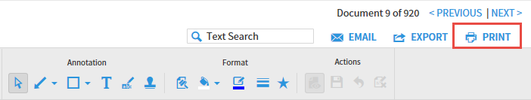

Once you have displayed a document from the Query Results window you can then print it to your local or network printer by pressing the PRINT push button shown above. Pressing this button will produce the following Print Range selection screen:
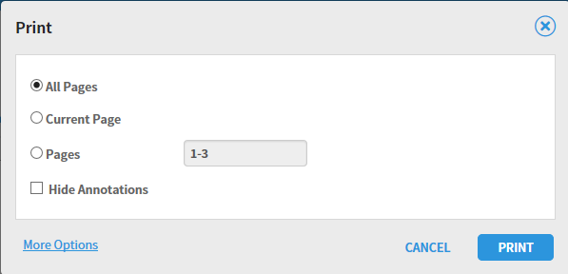

Chapter 4

How to Navigate Documents/Pages

Xtender Document - Page Toolbar
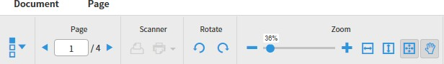

All documents – supported and unsupported – display with the standard document/page toolbar shown above. Supported file types will also display with an Annotation toolbar, as covered in Chapter 9 – How to Use Xtender Applications. Each of the icons/sections of the page navigation toolbar are covered below.

Thumbnail Icon – Show/Hide Thumbnails
The thumbnail toolbar allows you to turn thumbnail display on or off. When the arrow next to the icon is pointing down, thumbnails are displayed:

Clicking on the thumbnail icon changes the mode to hide thumbnails and the arrow will point to the right:

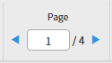
Page Navigation Icon

The page icon displays the current page number of a document and also provides you a method of advancing between pages in a document. To navigate between pages, simply click the right or left arrows of the navigation window:

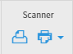
Scanner Icons – Select Scanner

If you have either a local or network scanner attached to your computer, the two scanner symbols shown above will display in the scanner section of the document/page toolbar. The icon on the right called the “Select Scanner” icon enables you to enable your scanner for use in Xtender. The drop-down arrow next to the Select Scanner icon also allows you to specify standard scanner attributes such as those shown below. Note that when possible, pages should be scanned in Black and White (if possible) with the smallest resolution possible (200 - 300,) to keep file sizes small.

Scanner Icons – Scan Page(s)
Once you have your scanner activated and both icons are highlighted, pressing the scanner icon on the left will start your scanner. As pages start scanning, Xtender will display the following message:
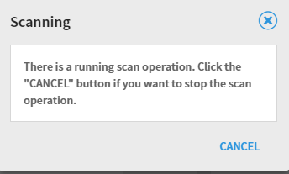

Rotate Icons – Rotate Page without saving page
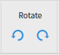

The rotate icons enable you to rotate a page either clockwise or counter-clockwise. Note that the Rotate icons will not display if the document is a foreign file. If you want to save the current rotated page, see the navigation method of rotate and save shown on the following page.

Rotate Page and Save Rotated Result:

If you want to rotate a page and save the page in rotated format, click the Page heading above the toolbar and select the Rotate and Save option, as shown below.

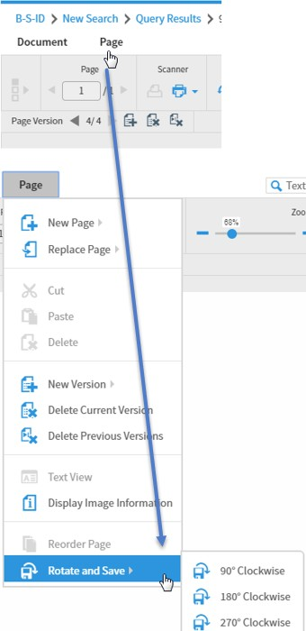

Zoom Icons – Zoom slider bar
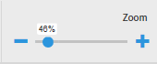

The zoom slider bar provides an easy method of zooming in and out on a page. A page can be enlarged or shrunk by simply sliding the dot left or right.

Zoom Icons – Fit Width, Fit Height or Fit to View

The fit width, height or fit to view icons allow you to resize the current page to maximize the viewing content either by width, height or overall size. The best icon to use will depend on the original size of the page when it was imported or scanned.

Document Thumbnails
Documents with two or more pages will open display with the Thumbnail window like the one shown below. The thumbnail view is helpful to see a page at a glance for navigation purposes. And, the thumbnails also provide a means of reordering pages by clicking and dragging a page to the order of the document you choose.
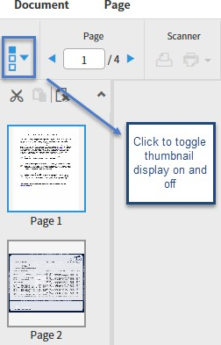

Note that thumbnail display can be toggled on and off. While thumbnails are useful, they can slow processing speed down.

Thumbnail Actions – Change Page Order
Pages can be reordered with a multi-page document one of two ways:
  - Using a click-and-drag method.
  - Cutting a page and pasting it in a different order.

Change Page Order by Clicking and Dragging
To move a page using the thumbnail display, click on the page you want to move and drag it up or down in the thumbnail window. Doing so will result in a confirmation window like the following:

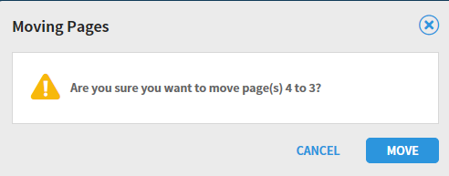

Change Page Order by the Cut and Paste Method:
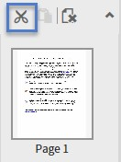

To move a page within a document using the Cut and Paste method, begin by clicking the Cut icon shown above. To paste the cut page, you must then click on the page you wish to paste the cut page after. In the example shown below, Page 2 was cut, Page 3 highlighted, and the Cut and Page icons are now both highlighted.
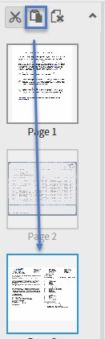

As with the click and drag method, you will be prompted to confirm the page move/paste action, as shown on the following page.

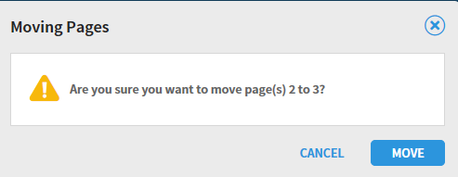

Click MOVE to confirm the page move action.

Chapter 5

How to Create a New Document

New documents can be created in Xtender by using the New Document tab described in this chapter or by creating a batch, as described in Chapter 6. To create/index a document using the New Document option, there are two methods:

- Import a document from your local file system.
- Scan a document from either a local or network scanner.

How to Import a New Documents – Toolbar Method

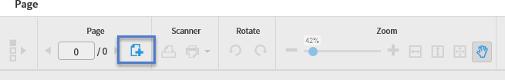

Xtender enables you to import electronic documents from your local file system by clicking on the Add Page icon on the toolbar as shown above. Clicking this icon will open the Add New Page screen shown below:

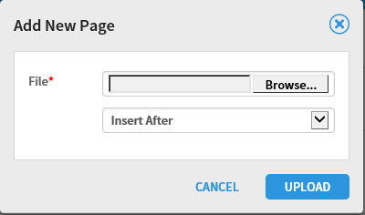

Note that there are 3 options for the placement of the page(s) you are importing. For the first page you are importing, the option doesn’t matter. But, after adding one or more pages, you can then insert or append new pages before (Insert Before) or after the previous pages (Insert After or Append.)
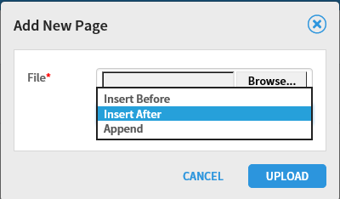

How to Import a New Documents - Click and Drag Method

The second method of importing a document uses a Windows click and drag technique. In the screen shot shown below, you’ll see the document import work space. To import a file from your local file system, you can simply click and drag the file into the work space. The document will then show the same as if you pointed to it and imported in the prior import section. Note that when you use the click and drag method, there’s no need to click on the Add New Page icon in the toolbar. Xtender will know you are adding a page. And, you will still have the 3 page positional options of Insert Before, Insert After or Append.

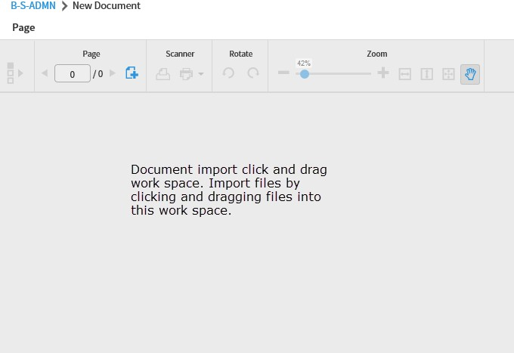

How to Create New Documents with a Scanner

The second technique of creating new documents in Xtender is the scanning method. If you have a local or network scanner available to your computer, Xtender 16.3 first requires the installation of supporting software called “Captiva Cloud Toolkit.” Please submit a ticket to the Technical Support
Center to have this software installed if you haven’t already done so. Your desktop technician should also turn on a user setting called “Enable Scanning” as part of your scanner setup.

How to Set up Your Scanner

Once you have Captiva Cloud Toolkit installed, click on the highlighted scanner icon shown in the toolbar below (the scanner icon with the drop-down arrow.) This action will prompt you to allow use of your scanner with Xtender. When prompted, click “Allow” to enable your scanner for use in Xtender:

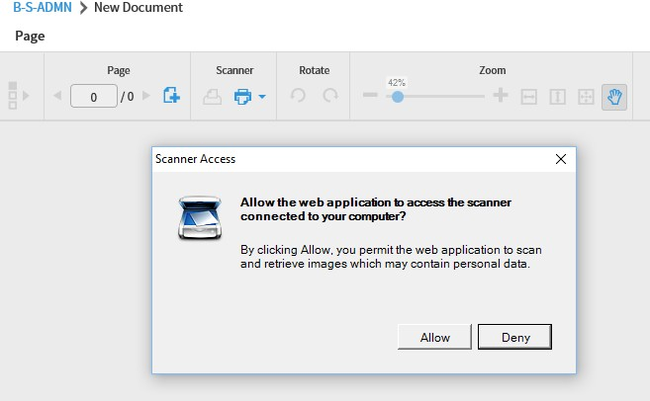

Once you have allowed scanner access by Xtender, you may then be prompted to select the scanner driver software you elect to use. If you see this screen and have the option, always select ISIS drivers – they work most efficiently with Xtender. If you don’t see this screen, that’s not a problem. Scanner software varies from device to device and this screen may not always display.

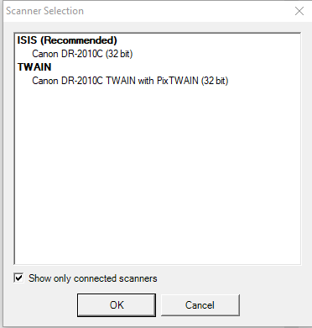

Once you have your scanner enabled for Xtender, you will notice that there are 2 scanner icons highlighted on the New Document toolbar. The scanner icon on the right enables you to configure settings for scanned documents such as the color format, resolution, etc.
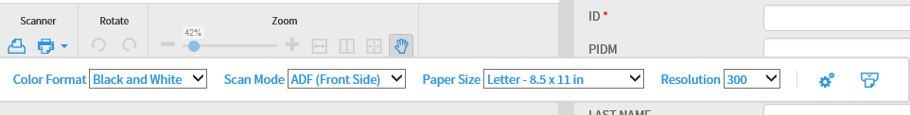

For more advanced scanner settings, click on the “Advanced Settings” gear icon on the right of the scanner toolbar. The settings you will be presented with will vary from scanner to scanner, but this example shows how scanner settings can be managed in general:
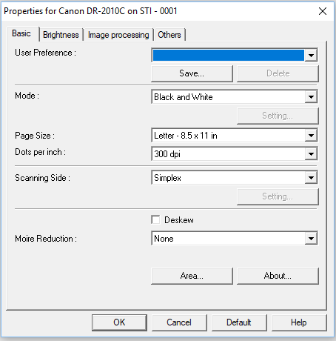

Note: If you see the following message display when you attempt to use your scanner, click CONTINUE to resume using your scanner.
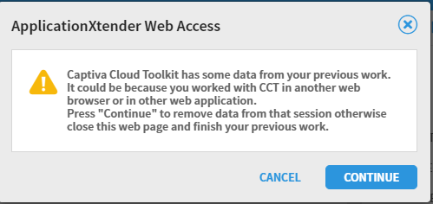

How to Scan a Document

When your scanner is selected, you should now see 2 scanner icons in the New Document toolbar. The icon on the left will enable you to scan one or more pages into Xtender:
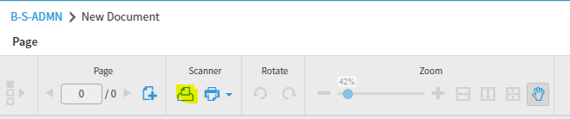

When you select the left scanner icon, your scanner will begin scanning operations. While the scanner is operating, you will see the following message display:
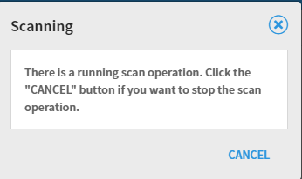

When your scanner has finished scanning, your page/document is now available for indexing! The example below shows a 2-page document with thumbnails, the page navigation toolbar, and the Annotation toolbar.
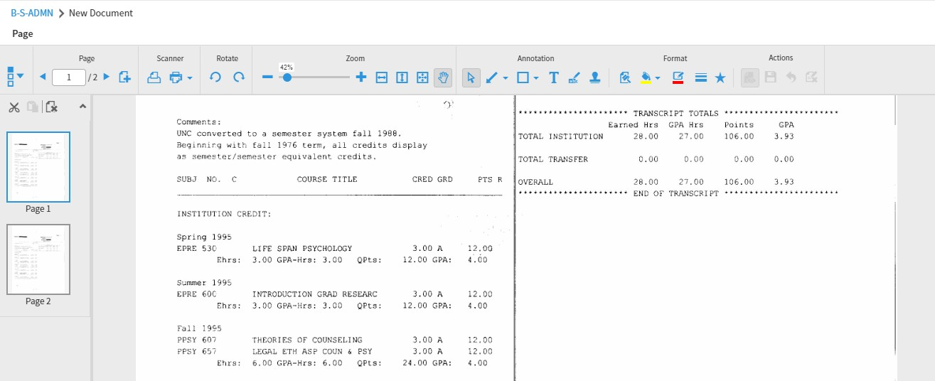

How to Index a Document

Whether you have created a document by importing, copying and pasting, scanning, the indexing steps will be the same. Xtender indexing values will vary from application to application, so bear in mind that the examples shown are for one application – B-S-ADMN.

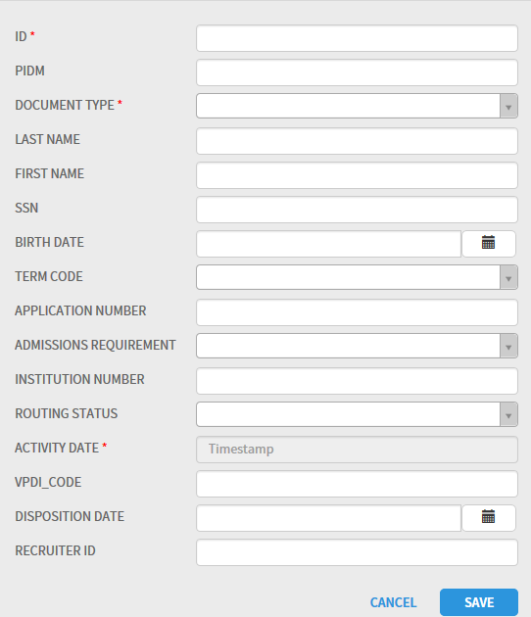
Indexing Window

Indexing Navigation, Rules and Tips

When indexing a document, there are certain rules in Xtender you must follow:

- Primary Index Values: In most cases, the primary index for applications will be the first field – ID in the case of B-S-ADMN. When you enter the first index value and tab off that field, Xtender will auto-fill related index values. For B-S-ADMN, that means that entry of an ID and tabbing off the field will auto-fill the following fields. This design of Xtender ensures that values related to the primary index value are always consistently used. This design also saves data entry time.

  - PIDM
  - LAST NAME
  - FIRST NAME
  - SSN
  - BIRTHDATE

- Required Fields: All fields marked with a red asterisk are required fields, as shown in the example below. Required fields must have a value entered in order for you to save a document.
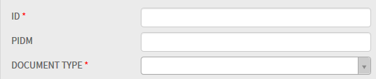

- Drop-down List Usage: Index fields with a drop-down arrow are predefined values to ensure consistent spelling and value usage. In the example below, a range of selectable values for the index value DOCUMENT TYPE are shown. The desired value can be entered by simply clicking one of the values in the drop-down list.
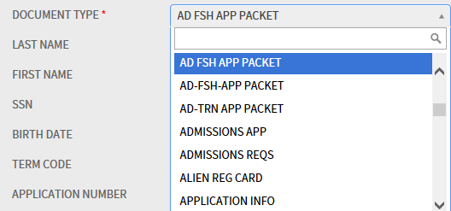

- Activity Date: Applications with an Activity Date will show the field as required, but it is an auto- filled field that requires no entry, as evidenced by the value “Timestamp” below.

Once all index values have been entered for a page/document, clicking SAVE will show the document along with its index values. At this point, the SAVE push-button changes to MODIFY, as shown in the example below:
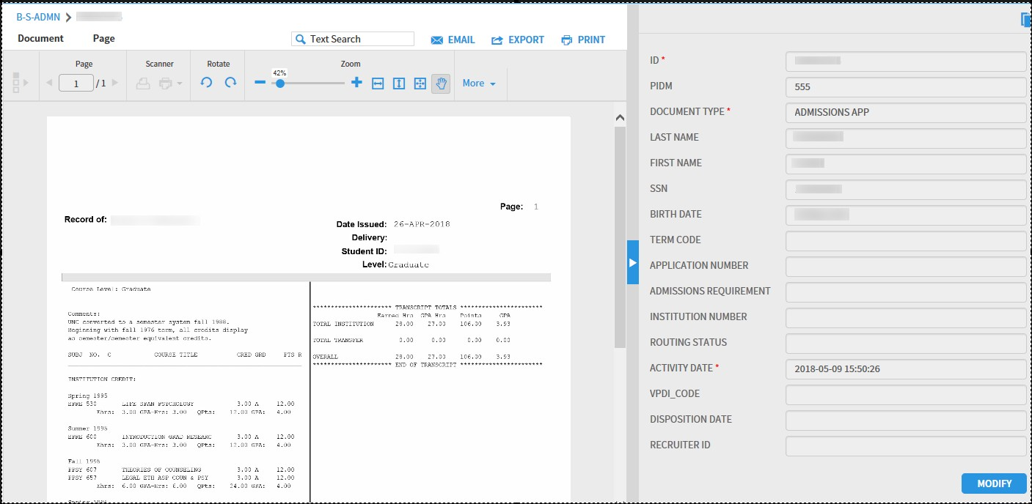

Unique Key Violation Message

Upon clicking the SAVE button for your document indexing, if you receive the following

message, it indicates that a document already exists in Xtender with the same index values you entered.
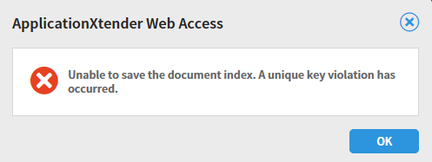

At this point, you have several choices of how to proceed:

You can change one or more of the index values to make the document indexes unique.

You can append the new document to the existing document with the same key values.

To append your new page/document to an existing document, click the OK button on the unique key error message and select the “Select Index” icon at the top of the Indexing window.

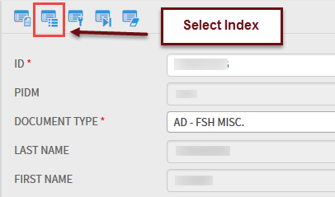

You will then be presented with one or more document choices to append your new document to. Once you have chosen the appropriate row, click on the Attach icon shown below and your new page(s) will be appended to the previously indexed document.
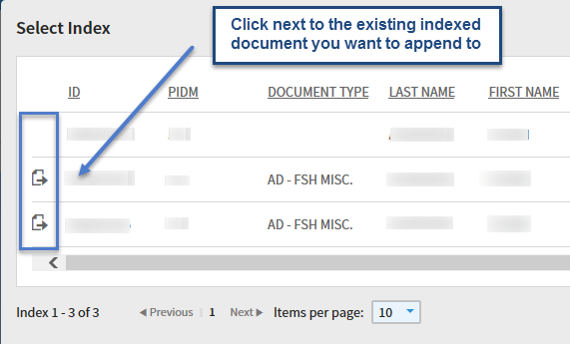

Chapter 6
How to Create a New Batch

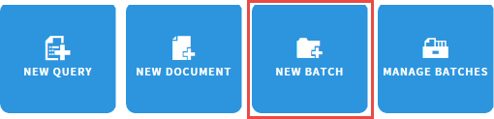
In addition to adding documents individually, Xtender enables you to create and index documents in batches. Batches are particularly useful when a department assigns the task of scanning multiple pages to an employee whose sole function is the scanning function. Once all pages have been gathered into a batch, the same or a separate individual can process the batch of pages/documents in bulk.

Creating a New Batch – Steps:

1. Click the New Batch icon. This action will produce the following Batch setup screen. Select the desired application for your batch, give it a unique name, and click Continue. The batch description field is optional.
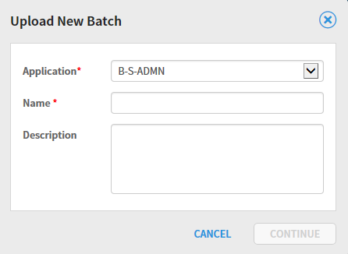

When your batch is created, you are presented with the same screen you see when selecting the Xtender New Document option:
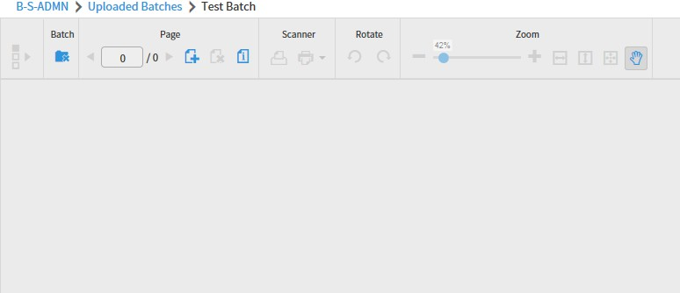

At this point, you can scan and/or import documents/pages as described in Chapter 4 – New Documents.

Chapter 7
How to Manage Batches

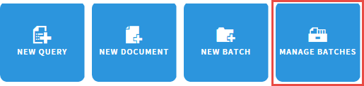

The Manage Batches option lists all batches that have been created either from a scanner or via imported pages/documents.
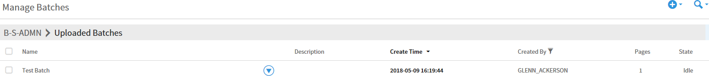

Batches can be managed one of two ways:

- Click the checkbox next to a batch, which allows you to delete a batch if it is in an idle state. If you have administrative privileges, you also have the option of resetting a batch status to idle.

- Click the down-arrow next to the batch name to open and process the batch:
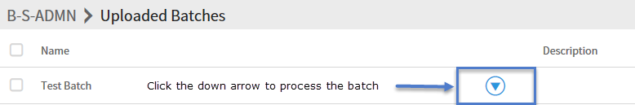

Clicking the down-arrow to process a batch produces the following 3 options for batch processing:

How to Index a Batch

The Batch Index Window allows you to both index a batch as well as add/modify annotations to each page/document in the batch. Annotations are electronic overlays such as a text notes, rubber stamps, text highlight, etc. Annotations are covered in Chapter 7 – Annotation processing. The toolbar for the Batch Index window will look familiar if you have indexed a document before:

Since the indexing of a page and/or document in a batch is the same as the New Document option covered in Chapter 4 – NEW DOCUMENTS, indexing won’t be covered here.

How to Edit a Batch

The Batch Edit option opens the Batch Information dialog box, enabling you to change the name or description of the batch. No further changes to the batch occur with this option.

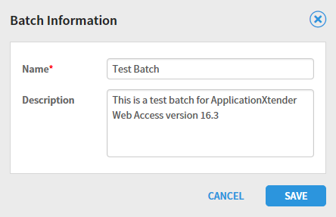

How to Import a Batch

The Batch Import option allows you to add pages to batches one of 3 ways:

- Click and drag a file from your local file system into the Batch window. Doing so will let you add that page to the existing batch.

- Click the Add Page icon on the batch toolbar. This option lets you select a file from your file system and add it to the batch. Note that the Page portion of the Batch Processing toolbar also lets you delete a page or display page information. The page information icon will display the format of the page/document/file. The file, for example, could be a PDF file, image file (.jpg, .tiff, etc.)
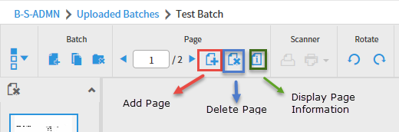

If the Add Page icon is pressed, you will be presented with a screen allowing you to point to a file in your local file system you wish to import into the batch:

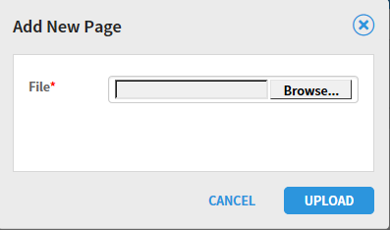

- The third option for adding a page to a batch is the Scan option. The scanner icon on the right will start your scanner and append the scanned pages to the end of the existing batch.

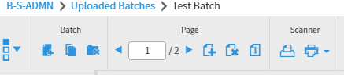

When the scanner icon is pressed, you will see the following message display:

Chapter 8

How to Use Xtender Annotations

Xtender enables authorized users to attach annotations to documents or batch pages to highlight content, comment on the contents of a page, or block (redact) content from viewing. Annotations are electronic overlays for an Xtender document. They don’t actually alter the document/page itself. Note that annotations can be added to image, PDF and text files, but can’t be added to foreign files (files like a Word or Excel document that can only be displayed by launching in your computer’s Word or Excel application.)

Annotations can also be modified at a later date and deleted if needed. And, while there is no limitation on the number of annotations added to a page, but be aware that a large number of annotations might slow or distort page rendering/displaying.

Annotation Types:

- Line annotations. This annotation type includes the straight line, freehand line, arrow and what’s called a polyline.
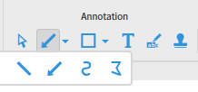

Polyline tip: In the example below, each change of direction of the line in the example was accomplished by a left-click of the mouse. To finish drawing the polyline, double-click to finish:

- Shape Annotations. Shape annotations include the rectangle, rounded rectangle, oval and the polygon:
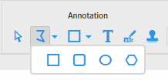

Note that for all shape annotations, the annotation Format options can be used. The format options allow you to change the fill color, line color, fill color and line width. The best way to
learn shape annotations is by trial and error – try different format options to see the wide array of shape annotations you can create.

- Text Annotations. Text annotations create a text box that be displayed either as an icon or box of text. To create a text annotation, click on the text icon and then click on the position you want the text annotation placed on the page. Once you click on the page position, the Edit Text Annotation dialog box appears as shown below. Note that in addition to typing in the Annotation text, you can format the text font, specify how the text annotation appears (Display as text box or icon,) and also set the color of the font and background.
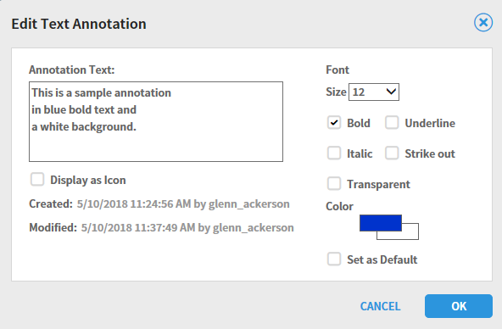

In the text annotation shown below, note that you can format the width of the text by pressing the Return/Enter key at the end of each line of text:
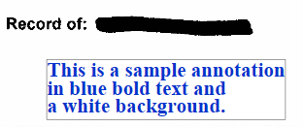

If the text annotation was designated with the “Display as Icon” option, it would appear as shown below:
To display a text annotation displayed as an icon, either double-click or right-click on the icon and select properties to display the annotation text.
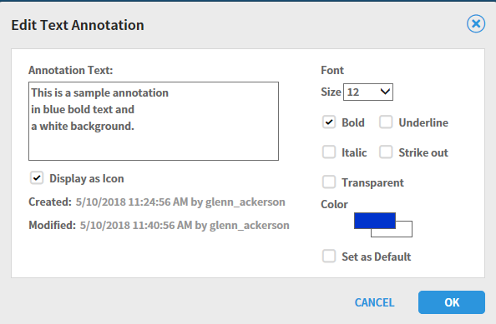

- Highlight Annotations. The highlighter annotation works like an electronic highlighter pen. Note that once you have highlighted a portion of a page, you can change the color and/or change the highlighted content to a redaction.

- Rubber Stamp Annotations. Rubber stamp annotations are predefined text annotations that are created and maintained by the Xtender administrator. One or more rubber stamps will appear for each Xtender application. Examples include “Received By” or “Processed By” with the date and userid of the person using the annotation. Unlike the text annotation, the text of the rubber stamp annotation is preset.
Rubber Stamp Icon on Toolbar

Rubber Stamp List to Choose from:
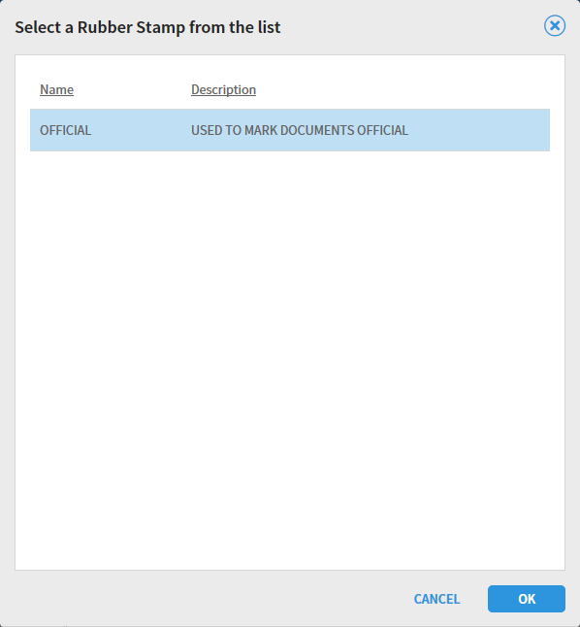

Sample Rubber Stamp:

Highlighter properties:
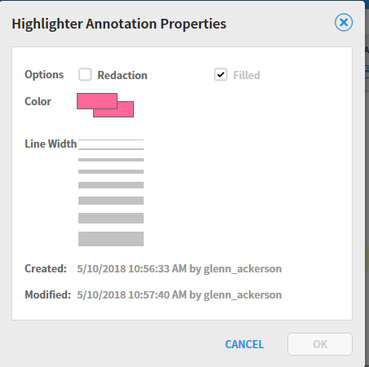

How to Modifying/Edit Annotations

Annotations can be modified by either double-clicking the annotation, or right-clicking on an annotation and selecting properties. Either action will produce a dialog box like the following:
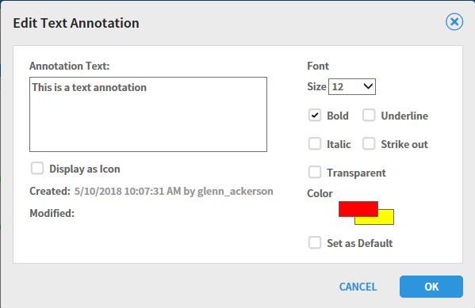

This option to edit an annotation allows you to change the annotation properties like font, color, etc.
Note that the edit annotation dialog box properties will vary depending on the annotation being edited.

How to Delete Individual Annotations

Annotations can be individually deleted one of two ways:

- Right-click the annotation and select the Delete option:
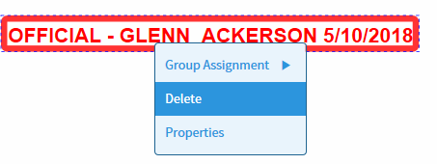

- Select the Delete icon from the Annotations Actions Toolbar:
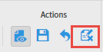

How to delete all Annotations for a document
Lastly, you can delete all annotations from a page by selecting the “Cancel Changes” icon from the Actions Toolbar. Be aware that this option removes all annotations and can’t be reversed:
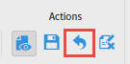

How to Hide Annotations

Annotation display can be toggled on and off by selecting the Show/Hide icon from the Annotation Action Toolbar:
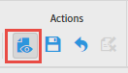

Appendix A

User Settings

Xtender has User Settings that can be customized for individual preference in processing.

Most of the default values should work well for most users, but several need to be changed if, for example, you are using a scanner with Xtender. This appendix will show suggested values recommended for optimal Xtender use.

Document View Settings

By default, foreign files (like Excel spreadsheets or Word documents,) display in the Web Access window with links such as those shown below:
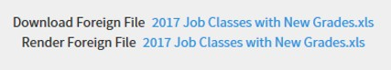

An alternative to the above display of foreign files allows you to display the foreign file content with the Web Access window as in the example below:
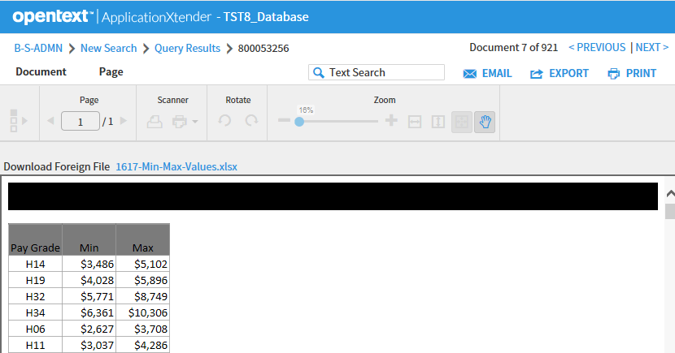

To enable this alternative method of foreign file display, see the User setting on the following page:

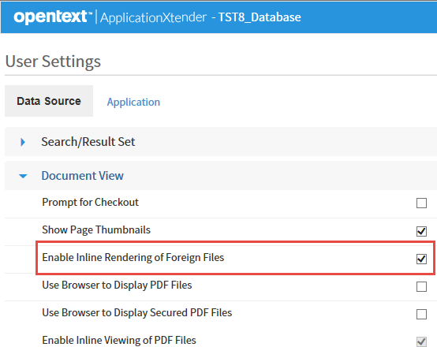

To display foreign file content in the Web Access window, check the “Enable Inline Rendering of Foreign Files checkbox on.

Import User Settings

If you have a scanner hooked up to your computer and plan on using it to scan documents in Xtender, you set the “Enable Scanning” checkbox on. Your desktop technician who installs the needed Captiva Toolkit software for Xtender scanning should have you turn this checkbox on.
