
Curriculum Information Management (CIM) System
User Guide
Academic Information Systems | Version 1.0 | 9/5/2019

Table of Contents

- About This Document
  - Intended Audience 2
  - CIM Policies and Additional Information 2
  - System Requirements 2
- Getting Started
  - Link 3
  - Logging on 3
- Using The System
  - Create a course proposal … 4
  - Create a program proposal 7
  - Process a course/program proposal (Workflow) 10

About This Document
- Intended Audience
This document is intended to be used by department representative, selected NJIT staff to propose new and updates to courses and programs, and Chairs, Deans, CUE/CGE members, CUE/CGE chairs, faculty senate, Provost office that approve these proposals, and Registrar and AIS staff who administer the system.

- CIM Policies and Additional Information
Curriculum Information Management (CIM) takes the entire curriculum process online, integrates, and builds on the CourseLeaf catalog software to provide a comprehensive, tightly integrated Curriculum and Catalog product. Program and course approval is tightly integrated with the catalog and the Student Information System (Banner).

The CIM module will import course information from Banner, provide customized pre-populated forms for authors, automatically create workflow without human intervention, identify all affected courses by a proposed change, track edits and comments, report on status, generate customized PDF files on demand for committee meetings, and assist in automatically updating the SIS at the end of the process. The CourseLeaf catalog software will then automatically update all catalogs with the approved data and approved programs data.

- System Requirements
The recommended browser for using the application is Google Chrome. However, it can also be accessed using other common browsers like Mozilla Firefox, Opera, Microsoft Edge and Safari.

Getting Started
- Navigation
Course management:
In a web browser*, navigate to Faculty/Staff Services under NJIT Highlander Pipeline, select Course inventory management under Academic & Faculty Services
Program management:
In a web browser*, navigate to Faculty/Staff Services under NJIT Highlander Pipeline, select Program inventory management under Academic & Faculty Services
Approve/Rollback:
In a web browser*, navigate to Faculty/Staff Services under NJIT Highlander Pipeline, select Workflow/ Approval page under Academic & Faculty Services
*Suggested browsers: Chrome, Firefox
- Logging On
The pages can be viewed once signed into the application.

CIM uses Single Sign-On. The UCID and password are used to log on, and if already logged on using Single Sign-On (displayed on the next page), it is not necessary to login again.

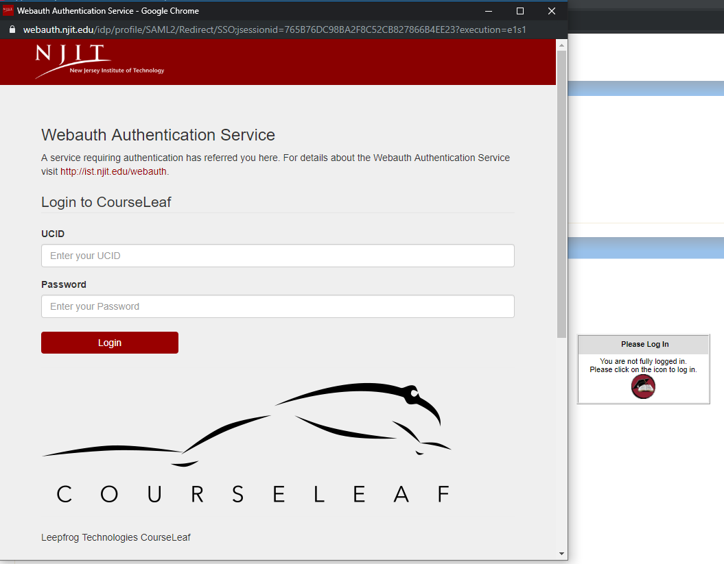

Using the System
- Create a course proposal
Only specified groups of user can access CIM and create proposals.
If you think you have the incorrect level of access, please contact ais@njit.edu.

Step-by-step instruction

- Navigate to course inventory management page using pipeline
- Login to the system
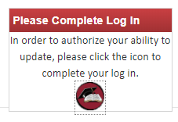
- Click ‘Propose New Course’

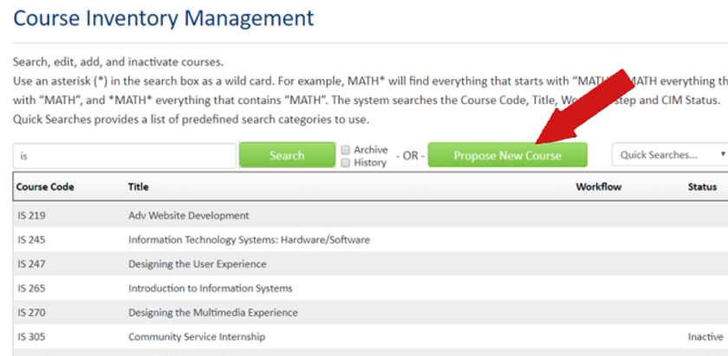

- Complete the course proposal
Note: fields with red border are required fields
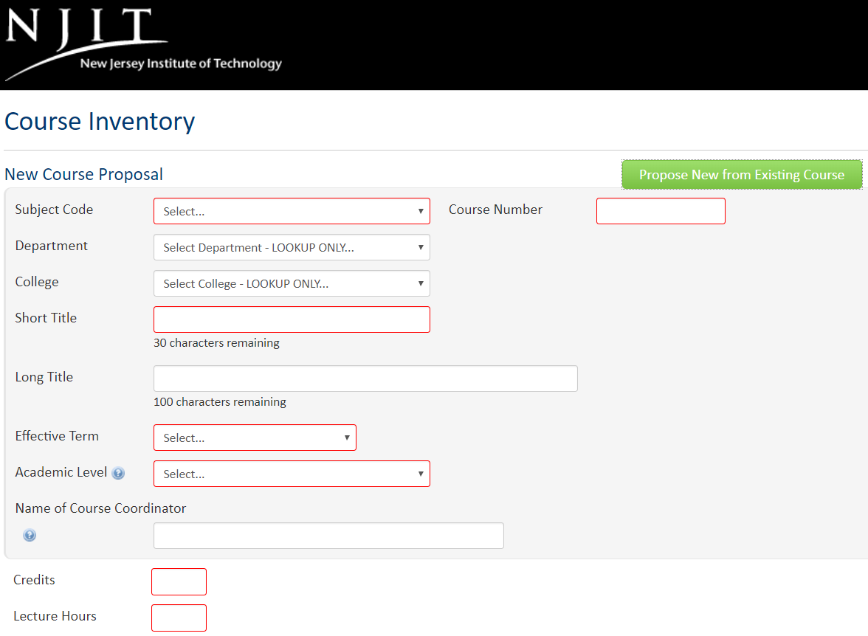
Note: User can also use the ‘Propose New from Existing Course’ feature to get a jump start
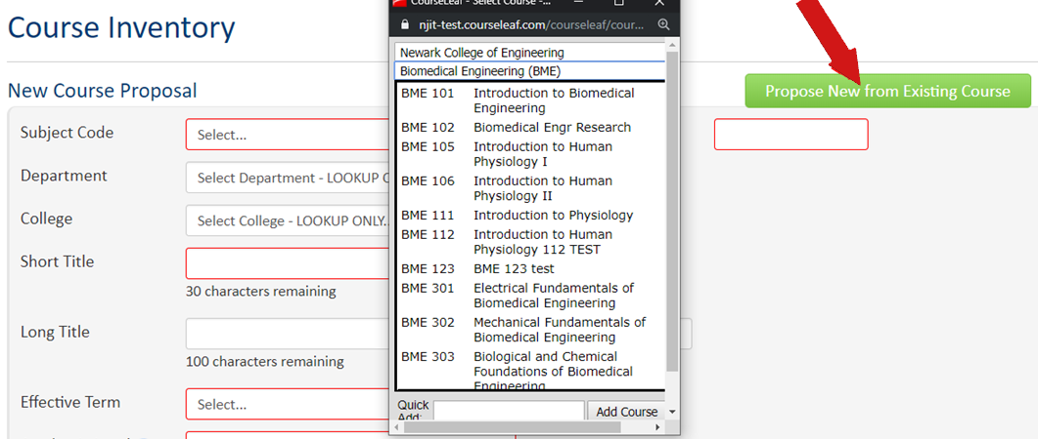
- Once user has completed the course proposal and it is ready for submission, click ‘Start Workflow’
Note: Once the workflow has begun, user cannot edit the form anymore until the next user in the workflow rollbacks the proposal.
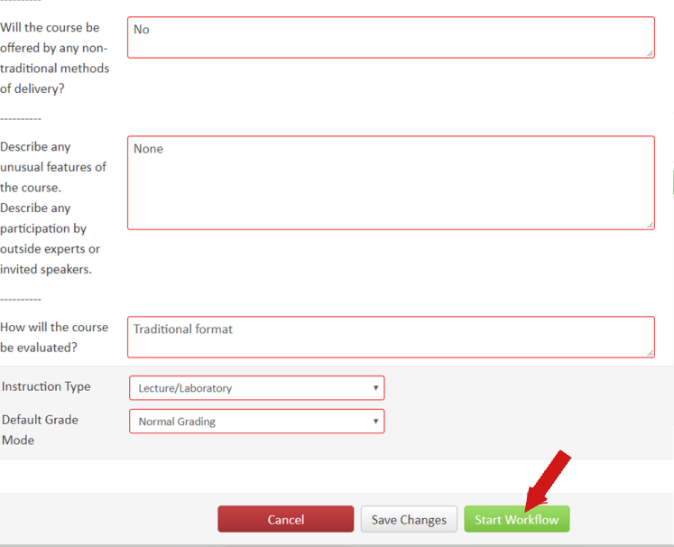
- The user can confirm their proposal’s status by checking the workflow under the course management console
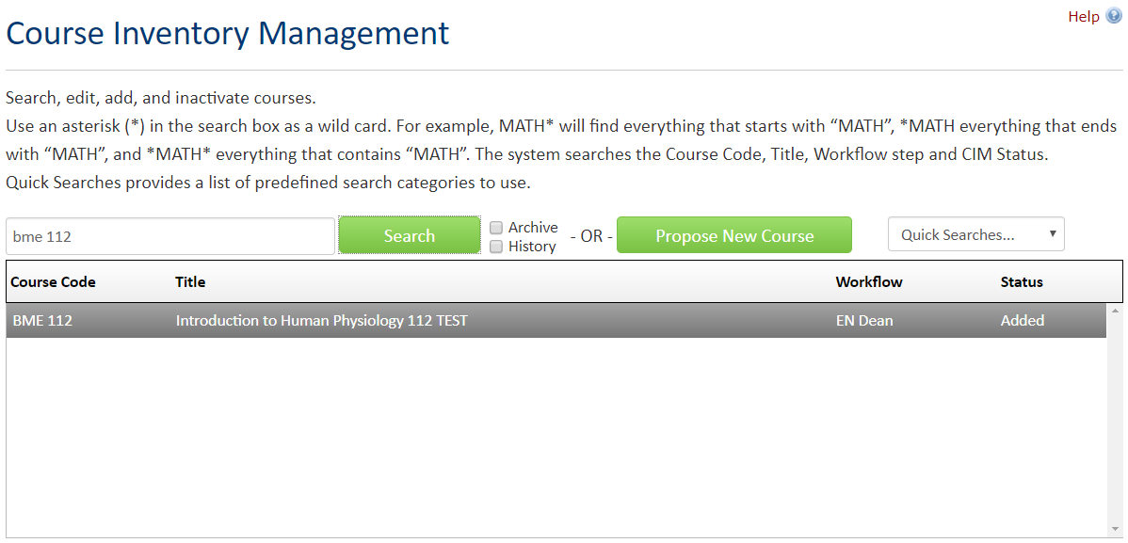
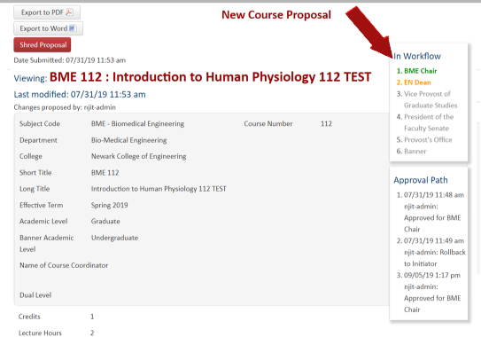

- Create a program proposal
Only specified groups of user can access CIM and create proposals.
If you think you have the incorrect level of access, please contact ais@njit.edu.

Step-by-step instruction

- Navigate to program inventory management page using pipeline
- Login to the system

- Click ‘Propose New Program”
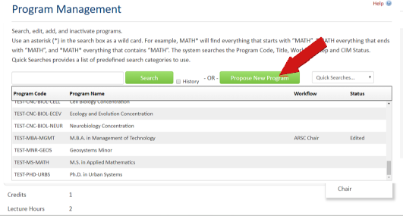
- Complete the course proposal
Note: fields with red border are required fields

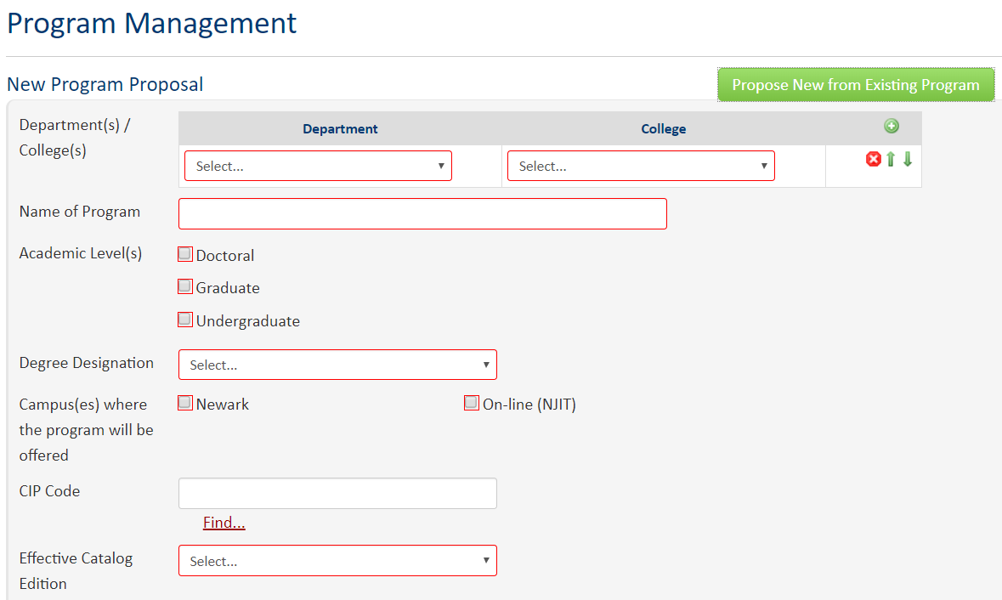
Note: User can also use the ‘Propose New from Existing Program” feature to get a jump start
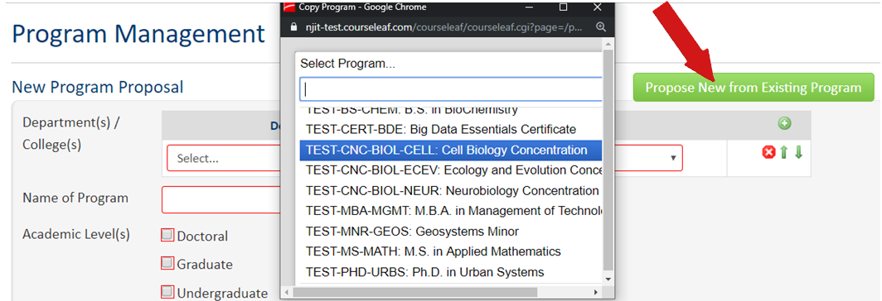

- Once user has completed the program proposal and it is ready for submission, click ‘Start Workflow’
Note: Once the workflow has begun, user cannot edit the form anymore until the next user in the workflow rollbacks the proposal.
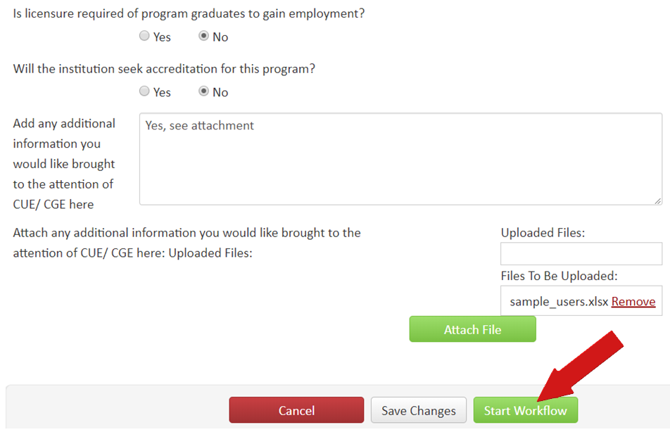

- The user can confirm their proposal’s status by checking the workflow under the program management console

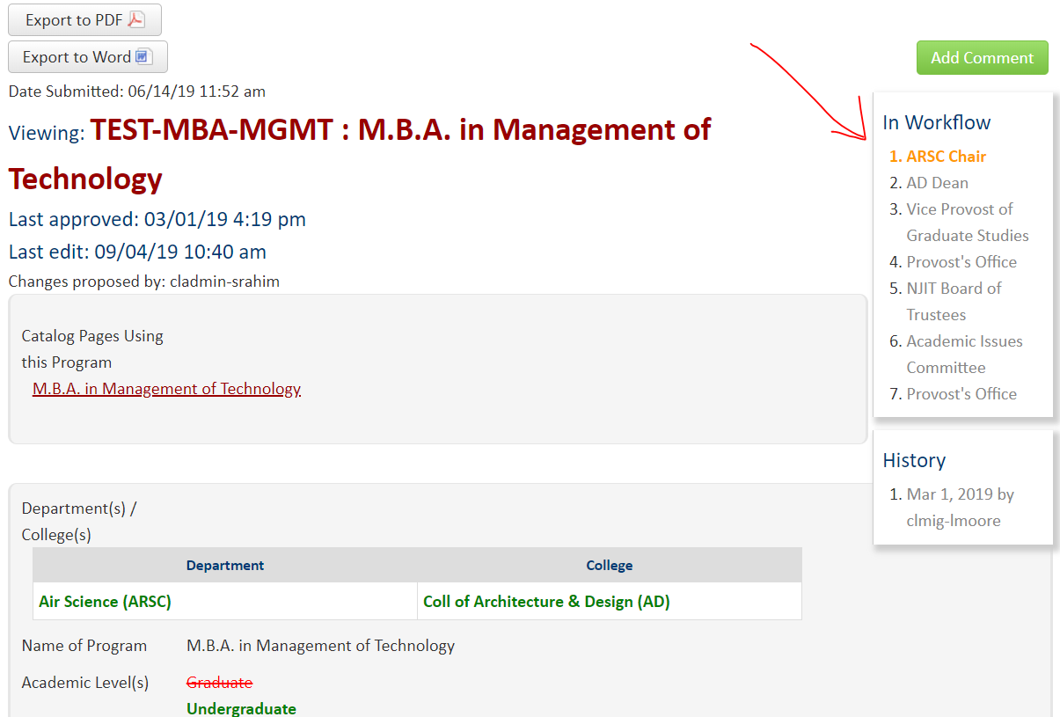
- Approve or Rollback a course/program proposal
Only specified groups of user can access CIM workflow and process proposals.
If you think you have the incorrect level of access, please contact ais@njit.edu.

Step-by-step instruction

- Navigate to Workflow/ Approval page using pipeline
Note: User who has pending proposal will receive email notification directly to access the proposal
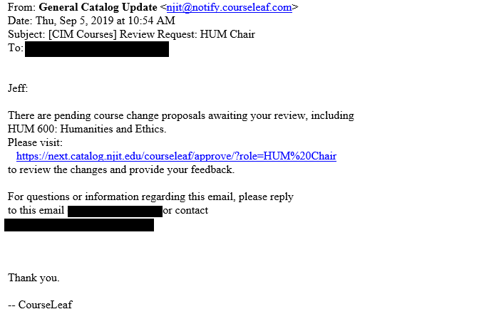
- Login to the system
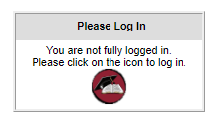
- Select a pending proposal from the console
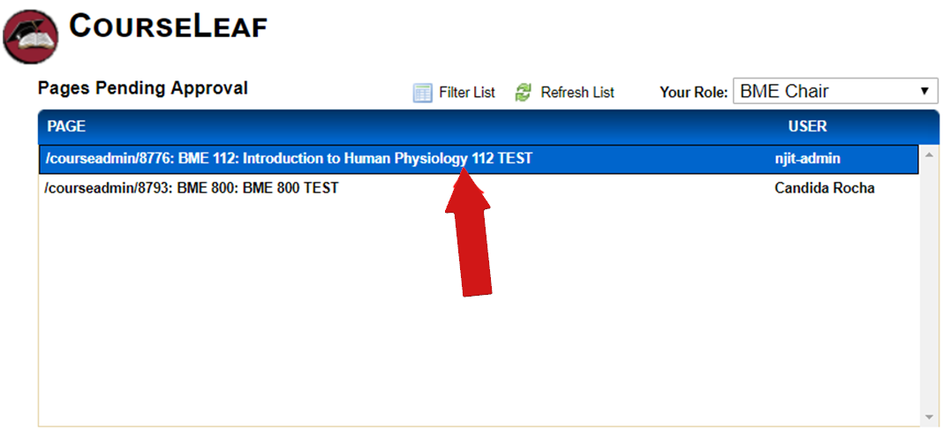

- Scroll down to the page
- Edit the proposal
- Rollback the proposal
- Approve the proposal
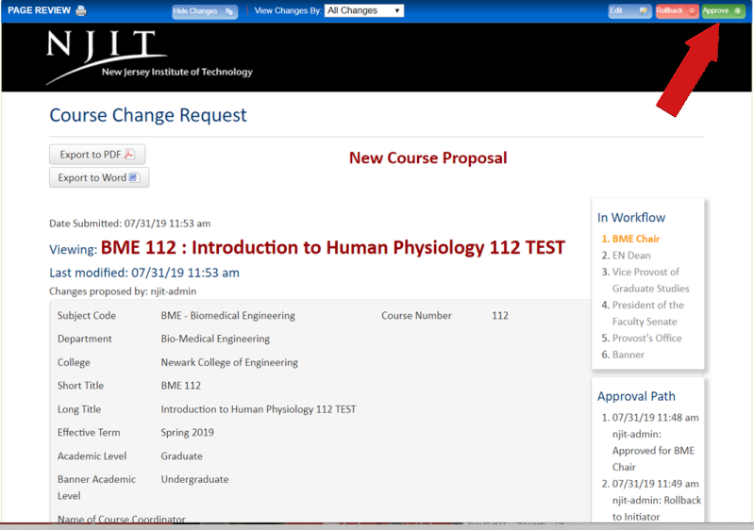
- Once the proposal is processed, it will be removed from the pending list.
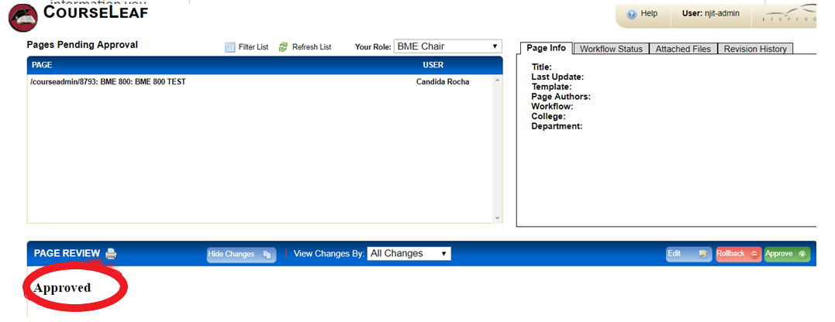
- The next existing user from the workflow will receive an email notification and continue to process the proposal

